*Florida International University*

*School of Computing and Information Sciences*

CIS 4911 - Senior Capstone Project

Software Engineering Focus

Final Deliverable

Car Recommendation System

**Team Members**

Zeev Feldbeine

Brenda Izquierdo

**Product Owner**: David Villegas.

**Instructor**: Masoud Sadjadi.

Copyright and trademark notices, restrictions on copying or distributing the documentation, information for contacting the issuing organization (reader’s comments), warranties, contractual obligations or disclaimers, and general warnings and cautions.

***Abstract***

*In the current car market, there are thousands of different cars, and lack of proper information about them. Thus, it is extremely difficult to get the right car for the right price, and it is even harder to sell a car for what is worth. The Car Recommendation System is the perfect tool to solve those vital problems. This system is a social web application that recommends cars based on user preference. The buyer can rate cars, view the seller’s contact information, and see where the cars are located in a map. In this paper, we will present the features and user stories of the system, its design, architecture, deployment, data scheme, use cases, diagrams and an overview of the whole project, which also includes the daily meetings and demos.*

**Table of Contents**

**Introduction 5**

Current System 5

Purpose of New System 6

**User Stories 7**

Implemented User Stories 7

Pending User Stories 89

**Project Plan 90**

Hardware and Software Resources 90

Sprints Plan 92

**System Design 97**

Architectural Patterns 97

System and Subsystem Decomposition 100

Deployment Diagram 100

Design Patterns 102

**System Validation 103**

**Glossary 195**

**Appendix 196**

Appendix A - UML Diagrams 196

*Static UML Diagrams 197*

*Dynamic UML Diagrams 200*

Appendix B - User Interface Design 207

Appendix C - Sprint Review Reports 216

Appendix D - Sprint Retrospective Reports 219

**References 224**

# Introduction

In the current car market, where there are thousands of different cars with different features and styles, the buyer is at a disadvantage when it comes to get the perfect car based on his preferences. Moreover, the process of buying a car is a complicated issue; customers spend entire days, weeks, even months searching for a car in local dealerships, newspaper announcements, online. Usually the sellers, who are expert in optimizing their profits, are telling any lie in the book to sell the most expensive and unattractive cars to customers. As a result, the buyer ends up purchasing a car he does not want with money he does not have. The customer does not only lose money but also his valuable time and the opportunity to buy a better car for a better price elsewhere.

The second problem that exists in the current car market, is that there is not an optimal way to sell a car for a fair value. Usually the seller needs to go again to the same dealership that they bought the car from. As a result the seller has a clear disadvantage and ends up being taken advantage of by the system that sold him a car in the first place. Moreover, as technology changes, humans tend to change as well to adjust to those technology advances, unfortunately it is very hard for people to keep up with all the different cars that exist and come out in the market, consequently it is extremely hard to establish beneficial transaction between buyers and sellers.

## Current System

Buyers who want to search for a car and get proper and diverse information about different cars, models, styles, horse power, engines, and many other feature usually get that information in a form of an advice or recommendation from the dealer himself, whose only purpose is to sell the car for the highest price, without considering the buyer preference. Therefore they go to car dealerships or to car shows, for the purpose of getting information, even if it’s not fair information. Many buyers usually get information about cars from their friends who themselves received their knowledge from other people, as a result this infinite loop creates a large population of buyers who do not know how and what car to buy for a fair value. Moreover, when selling a car, the owner usually goes to CarMax or other dealerships and end up selling their vehicles for less than its worth. The other way people usually sell a car is by listing it in Craigslist, but unfortunately Craigslist does not enforce any legality over the cars they sell; not surprisingly, this website is very famous for being a hotspot for scammers who cheat and steal money from buyers and sellers alike. All in all, there are many website and non-web related tools that provide a marketplace for sellers and buyers, however, they all fail to provide the relevant information needed for an optimal vehicle transaction.

## Purpose of New System

Recommendation systems are taking more importance in online businesses, where the ability to propose a new item or product that a user will like can increase sales substantially. In this project, we propose to implement a web page where users can view certain types of items, for example cars, and give their feedback about them, either explicitly (thumbs up / down, likes, ratings...) or implicitly (clicking on item, spending time reading its description, sharing it..) Then, the system will run algorithms to come up with similar items to show to the user, and optionally collect feedback about the quality of the recommendation. Algorithms can range from simple similarity measures, to more complex machine learning models such as the SVM. Different topics of Data Science were applied, such as retrieving information, cleaning it for processing and storing it, evaluating algorithms for recommendation, and implementing big data processing pipelines.

In other words, the system will study the user input throughout time, and recommend cars based on machine learning algorithms. This way the user can look into prospective cars that meet his or her expectations.

# User Stories

This chapter describes the main details and planning involved in creating the Car Recommendation System project. It is composed of six sprints, each of them with a time length of two weeks. As the reader dives into each sprint and each user story, he shall see the functionalities implemented throughout this semester and the main logic description (using UMLs and other diagrams). The user stories chapter is perhaps the most important chapter of all, since it describes our work in terms of logic and timing. Each user story consists of a title, description, acceptance criteria, and diagrams used to explain the concept and the logic behind the implementation. The team members expressed their talent and skills in implementing the use cases (user stories) as well as in describing them each sprint review. For a complete picture of the system logic and planning please do take a look at the UML section, as it is directly related to this section in regards of describing the implementation and work involved.

## Implemented User Stories

# User Story - Log In #745

* Description: As a user I want to be able to log in to the website so that I use the website features.

### Acceptance Criteria:

1. The user’s email and password are the only credentials to login.
2. The system must be able to corroborate the credentials and respond appropriately.
3. The user must stay in the login view if credentials entered are wrong.
4. The user must be able to log out at any moment.

## Use Case

|  |
| --- |
| **Use Case ID:** CRS_LoginMain_01 - Login Page |
| **Details:**   |  | | --- | | **Actors:** User | | **Pre-conditions:** The user has successfully loaded the web page. | | **Description:**   |  |  | | --- | --- | | User | System | | 1)  Use case begins when user opens the login-registration page. | 2) The system shall provide the user with a form for login entry | | 3) The user shall enter the following data: login email and login password. (All the fields are required) |  | | 4) The user shall then send the login request by selecting  the login button. | 5) The system shall then notify the user if the login request was submitted correctly. | |  | 6) When a successful login request is received the system shall generate a  login session. | |  | 7) Use case ends when the login request is stored in the session table of the  system database. | | | **Post-conditions:**   |  | | --- | | 1)  The number of session requests stored in the session table of the system  database has increased by one. | | 2) The login authentication request has been saved in system log and the  user session has been instantiated. | | |
| **Alternative Course of Action:**   |  | | --- | | 1) In step D.4 (step 4 of Description section) the user has the  option to cancel the login request. | | 2) In step D.5 if any of the required fields are blank the system shall request the  user to fill in the appropriate field. | |
| **Exceptions:**   |  | | --- | | 1)  The login link on the web page is not active. (if  user is already logged in) | | 2) After the user enters the required login data the login button is  not active. | |
| **Related Use Cases:** None |
| **Decisions Report:**   |  | | --- | | **Frequency:** On average 1.5 requests are made by the user  per application execution. | | **Critically:** High. Allows the user to log into the system. | | **Risk:** High. | |
| **Modification History:**   |  | | --- | | **Owner:** Zeev Feldbeine | | **Initiation date:** 01/21/2016 | | **Date last modified:** 01/21/2016 | |

## Use case  Diagram

## https://lh5.googleusercontent.com/7V0cn7IwGqF6pWphGrTIhPW9WnBs_X-S5hczQo-XVoC19rkTarTiZ2mP3iV8_h-CmvefCgEHxY6-p7A55DEGoWgmw0P1C34iXi1eJDMX5paCk6tInS5PK3XWjAq-qBxXhZyXG98m

## Sequence Diagram

## https://lh3.googleusercontent.com/K5fecSAmudRdJd8SKkxgrnhCvYDzxQb9St_jXLsjEMjx9sRl4B9nPMn8wSBd7pK9_eBeWjTWQEoOnsQC0LjSFVULBWv11NCZG0pX412k16g9vDfBOGBi_qAHucAfo_janxkd1KSO

## Class Diagram

## https://lh4.googleusercontent.com/JDfucjOm1iwXPzD0ZtTXzK5XBHs1ZP7pRB5VV7Ri7KP0MvmrvHKE1oUgv2wTR7ZpeZIasedEa_05wwtE4CkTqmzIKKXHB3C1GWtwtZbUIxbUrrvp9XVC11tUXCX-_GRezOjPGem_

# User Story - Log Out/Menu #748

* As a user I want to log out so that I can delete my cookies and be able to log in with different user

### Acceptance Criteria:

1. Upon clicking the logout option the system should log the user out
2. User must be able to login back at any time

## Use Case

|  |
| --- |
| **Use Case ID:** CRS_Logout_02 – User Logout |
| **Details:**   |  | | --- | | **Actors:** User | | **Pre-conditions:**  1) The user has successfully loaded any system web page.  2) The user has successfully logged into the system. | | **Description:**   |  |  | | --- | --- | | User | System | | 1)  Use case begins when user clicks on the menu button. | 2) The system shall provide the user with a dropdown (list of links) to choose from. | | 3) The user shall click the Logout link. | 4)When a successful logout request is received the system shall terminate  the user session. | |  | 5) Use case ends when the logout request is deleted from the session table  of the system database and the system navigates to login page. | | | **Post-conditions:**   |  | | --- | | 1)  The number of session requests stored in the session table of the system  database has decreased by one. | | 2) The logout request has been saved in system log and the user session  has been deleted. | | 3) The menu dropdown button no longer exists and is replaced by the menu  register/login button group. | | |
| **Alternative Course of Action:**   |  | | --- | | 1) In step D.3 (step 3 of Description section) the user has the  option to cancel the logout request by clicking the menu button to close the  dropdown instead of clicking the Logout link. | |
| **Exceptions:**   |  | | --- | | 1)  The logout link on the menu is not active. | |
| **Related Use Cases:** None |
| **Decisions Report:**   |  | | --- | | **Frequency:** On average 1 requests are made by the user per  application execution. | | **Critically:** Low. Allows the user to logout of the system. | | **Risk:** Low. | |
| **Modification History:**   |  | | --- | | **Owner:** Zeev Feldbeine | | **Initiation date:** 01/21/2015 | | **Date last modified:** 01/24/2015 | |

## Use Case Diagram

## https://lh5.googleusercontent.com/H0d0h6tLxKThLkY_rC1ClqGhiw__pltmJ4AFiUkVPrnt3tNSpvqFWv4BoE45vzo4L4-rddzq5aM4RiqQ16jy7CSxnpDEFGXryXdLJ0mU886Jt96AlOJ1EKaXAtLAiG72WFPGNZ5e

## Sequence Diagram



## Class Diagram

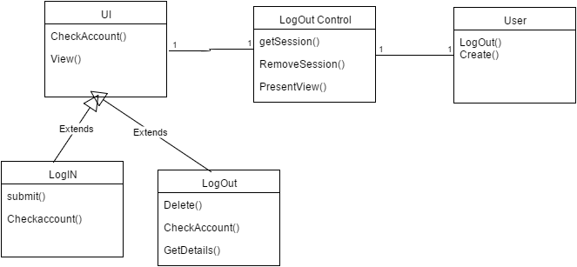

# User Story - Favorites #750

1. **As a registered user I want to be able to see the cars I gave thumbs up to displayed in a list so I can remember my preferences**

### Acceptance Criteria:

1. **The system must to be able to present a list of cars that the user gave a thumbs up to.**
2. **The user must have the prerogative of removing cars from that list.**

## Use Case

|  |
| --- |
| **Use Case ID:** CRS_CarFavorites_06 |
| **Details:**   |  | | --- | | **Actors:** User | | **Pre-conditions:**  1) The user has successfully loaded any system web page.  2) The user has successfully logged into the system.  3) The user has successfully liked cars and entered to the favorites page. | | **Description:**   |  |  | | --- | --- | | User | System | | 1)  Use case begins when user enter to the favorites page | 2) The system shall provide the user list of cars that the user liked | | 3) the user shall be able to navigate between the different cars in the list | 4)when user clicked on the full info button, the system shall present the full car data | |  | 5) Use case ends when the system do not receive any user inputs or end of data or when the user gets out of the favorites page | | | **Post-conditions:**   |  | | --- | | 1)  the system continued to present car list and info to the user | | 2) the system shall update the list based on user favorites history | | |
| **Alternative Course of Action:**   |  | | --- | | 1) In step D.3 (step 3 of Description section) the user has the  option to delete a favorite | |
| **Exceptions:**   |  | | --- | | 1)  the system can not present the car info, or data error | |
| **Related Use Cases:** None |
| **Decisions Report:**   |  | | --- | | **Frequency:** on average 20 requests are made by a single user | | **Critically:** medium, not essential for the system | | **Risk:** medium. | |
| **Modification History:**   |  | | --- | | **Owner:** Zeev Feldbeine | | **Initiation date:** 02/28/2016 | | **Date last modified:** 02/28/2016 | |

## Use Case Diagram

## https://lh4.googleusercontent.com/2dl0boTxmH1VYr7pLkDsvbAs23x4ZSxfVqwoi6JpI3iY3u6hs0CxrbBZjTuHRItvKHc5jg5LgAmuaZ5vAcrRDiOWlF15jQ4imHvPOn918ejIEZz70jNP_8SGzhTqo6PEMjN7aABb

## Sequence Diagram



## Class Diagram



# User Story - car view slide #752

* As a user I want to be able to see a cars displayed in a window page so I can select my favorite car to purchase

### Acceptance Criteria:

1. The system must pull data from the database about the cars.
2. The system must pull data from the database about the seller, namely the name, phone number and email address.

## Use Case

|  |
| --- |
| **Use Case ID:** CRS_CarDisplay_04 |
| **Details:**   |  | | --- | | **Actors:** User | | **Pre-conditions:**  1) The user has successfully loaded any system web page.  2) The user has successfully logged into the system.  3) use is in the homepage | | **Description:**   |  |  | | --- | --- | | User | System | | 1)  Use case begins when user enter to the home page | 2) The system shall provide the user a slide with car info | | 3) the user shall be able to navigate between the different cars | 4)when user clicked the next button, the system shall present the next car | |  | 5) Use case ends when the system do not receive any user inputs or end of data. | | | **Post-conditions:**   |  | | --- | | 1)  the system continued to present car info toe the user | | 2) the system saves the user history data, from his selections | | |
| **Alternative Course of Action:**   |  | | --- | | 1) In step D.3 (step 3 of Description section) the user has the  option to favorite a particular image | |
| **Exceptions:**   |  | | --- | | 1)  the system can not present the car info, or data error | |
| **Related Use Cases:** None |
| **Decisions Report:**   |  | | --- | | **Frequency:** on average 10 requests are made by a single user | | **Critically:** high, this is the main objective of this project | | **Risk:** medium. | |
| **Modification History:**   |  | | --- | | **Owner:** Zeev Feldbeine | | **Initiation date:** 02/02/2016 | | **Date last modified:** 02/02/2016 | |

## Use case  Diagram

## https://lh5.googleusercontent.com/KMAo2syxbwELv6O8QjK01i55ovLEJUH15-jmzs8Q4anI_Wj8CKUmtl4fDcPBl7mYgxJEKs2-fjdu1TGRve6kRI0nLX6GBMDrNlk-78DL5XLvAzcb8IFcP2mIusSlwLXHVc711UdD

## Sequence Diagram

## https://lh3.googleusercontent.com/PKJPFmvbDRbh-mbXHvfUspjhr6CK-q1lEHtVzUlpQsRGmZm5zJnH9J5i_nScfCYlEPN8PbXf753vqQJdfW88r79YhFmjNRAQYbKR8ntGIYc7RWbcVPpUD-wgA6FyPZcn0o1eTyqa

## Class Diagram



# User Story - Car Info #802

* as a user I want to be able to look for my selected car information so that I can get better decision if to purchase the car or not.

### Acceptance Criteria:

1. the user must be able to click on the info button
2. the system must present the information for that specific car

## Use Case

|  |
| --- |
| **Use Case ID:** CRS_CarInfo_05 |
| **Details:**   |  | | --- | | **Actors:** User | | **Pre-conditions:**  1) The user has successfully loaded any system web page.  2) The user has successfully logged into the system.  3) user is in the homepage  4) the system displayed cars | | **Description:**   |  |  | | --- | --- | | User | System | | 1)  Use case begins when user enter to the home page | 2) The system shall display the cars | | 3) the user shall be able to click on the info button,contact button or the like button | 4)when user clicked the info button, the system shall present car info,  when user clicked the like button, the system shall save the carid of the car.  when user clicked the contact button, the system shall pop a seller contact information | |  | 5) Use case ends when the system do not receive any user inputs or end of data. | | | **Post-conditions:**   |  | | --- | | 1)  the system continued to present car info to the user | | 2) the system saves the user history data, from his selections | | |
| **Alternative Course of Action:**   |  | | --- | | 1) In step D.3 (step 3 of Description section) the user has the  option to po pass to the next page, or to re-click the button to cancel the effect. | |
| **Exceptions:**   |  | | --- | | 1)  the system can not present the car info, or data error, or database errors. | |
| **Related Use Cases:** None |
| **Decisions Report:**   |  | | --- | | **Frequency:** on average 10 requests are made by a single user | | **Critically:** high, this is the main objective of this project | | **Risk:** medium. | |
| **Modification History:**   |  | | --- | | **Owner:** Zeev Feldbeine | | **Initiation date:** 02/12/2016 | | **Date last modified:** 02/12/2016 | |

## Use case  Diagram

## https://lh6.googleusercontent.com/tw5EyP3Bs1Q-irXquHg9ZgDn_2DAdeXq3cA1YWnjdIstuhmVkWBVJjFqPx3u87ApUUjOGeSLgNIUn-PWF9NX4JoYUHbfkqzAJEA3S8nYQUGtr3XiegP0x0sGp_VvYg0fLCFClJ4b

## Sequence Diagram

## https://lh4.googleusercontent.com/yMSy3cyYIqdGJMSEAMCirLpz-ECJVAs9T1klWqw1_oMz94zqVe2sB6GuQv8MROwYa8Nxc8I8q55uhUZmZ-s3WGPEmH0c7CHumuS_NP3HpbIEkAlqaaQW4zVOZbzk2B_bP5arxU-V

## Class Diagram



# User Story - System Recommendation #746

1. As a user I want to be able to search for the perfect car so that I can save money and time efficiently

### Acceptance Criteria:

1. A search box must be provided so that the user can enter keywords indiscriminately.
2. Upon the first search, the system must continue to present the use with a list of cars that have similar attributes.

## Use Case

|  |
| --- |
| **Use Case ID:** CRS_Recommendation _07 |
| **Details:**   |  | | --- | | **Actors:** User | | **Pre-conditions:**  1) The user has successfully loaded any system web page.  2) The user has successfully logged into the system. | | **Description:**   |  |  | | --- | --- | | User | System | | 1)  Use case begins when user enter to the home page | 2) The system shall provide the user list of cars based on history of favorites | | 3) the user shall be able to navigate between the different cars in the list | 4)when user click right or left button, the system shall present the next car based on use preference.  If user click on like button the system shall recalculate the order and the list of the cars to present to the user. | |  | 5) Use case ends when the system do not receive any user inputs or end of data or when the user gets out of the home page | | | **Post-conditions:**   |  | | --- | | 1)  the system continued to present car list and info to the user | | 2) the system shall update the list based on user favorites history | | |
| **Alternative Course of Action:**   |  | | --- | | 1) In step D.3 (step 3 of Description section) the user has the  option to delete a favorite  2) In step D.3 (step 3 of Description section) the user has the  option to to click info or contact info | |
| **Exceptions:**   |  | | --- | | 1)  the system can not present the car info, or data error | |
| **Related Use Cases:** None |
| **Decisions Report:**   |  | | --- | | **Frequency:** on average 50 requests are made by a single user | | **Critically:** High, essential for the system | | **Risk:** High. | |
| **Modification History:**   |  | | --- | | **Owner:** Zeev Feldbeine | | **Initiation date:** 02/28/2016 | | **Date last modified:** 02/28/2016 | |

## Use case  Diagram

## https://lh4.googleusercontent.com/bUeGwpb_75LPWL-_Te0Knd-qTS_qD9D9eQqR11Bc5QqeTBeMDltD-JXAOogWdt8_7Ja_Xqy2ggMlpYu5gpIhYh2BIpV2mzxbdN4wHiFxqiCYCbdXdCk99nvW-HOiits_7VfhhX6J

## Sequence Diagram



## Class Diagram



# User Story - #837 view cars in homepage

1. as a user I want to be able to see all the cars in a list of three so that I can have better visualization of the cars for sale

### Acceptance Criteria:

1. A home page must  provided so that the user can search indiscriminately.
2. Upon the first search, the system must continue to present the use with a list of cars that have similar attributes.

## Use Case

|  |
| --- |
| **Use Case ID:** CRS_list_Recommendation _09 |
| **Details:**   |  | | --- | | **Actors:** User | | **Pre-conditions:**  1) The user has successfully loaded any system web page.  2) The user has successfully logged into the system. | | **Description:**   |  |  | | --- | --- | | User | System | | 1)  Use case begins when user enter to the home page | 2) The system shall provide the user list of cars based on history of favorites | | 3) the user shall be able to navigate between the different cars in the list | 4)when user move down, the system shall present the next car based on use preference.  If user click on like button the system shall recalculate the order and the list of the cars to present to the user. | |  | 5) Use case ends when the system do not receive any user inputs or end of data or when the user gets out of the home page | | | **Post-conditions:**   |  | | --- | | 1)  the system continued to present car list and info to the user | | 2) the system shall update the list based on user favorites history | | |
| **Alternative Course of Action:**   |  | | --- | | 1) In step D.3 (step 3 of Description section) the user has the  option to delete a favorite  2) In step D.3 (step 3 of Description section) the user has the  option to to click info or contact info | |
| **Exceptions:**   |  | | --- | | 1)  the system can not present the car info, or data error | |
| **Related Use Cases:** None |
| **Decisions Report:**   |  | | --- | | **Frequency:** on average 100 requests are made by a single user | | **Critically:** medium, essential for the system | | **Risk:** low. | |
| **Modification History:**   |  | | --- | | **Owner:** Zeev Feldbeine | | **Initiation date:** 04/01/2016 | | **Date last modified:** 04/01/2016 | |

## Use case  Diagram

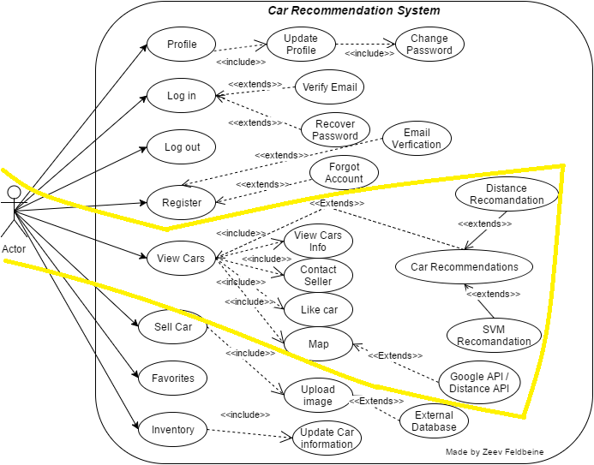

## Sequence Diagram



## Class Diagram



# User Story - #838 map view in car item

1. as a user I want to be able to see the location in the map so that I can get better selections

### Acceptance Criteria:

1. A home page must  provided with list
2. Upon the first map search, the system shall present the cars info

## Use Case

|  |
| --- |
| **Use Case ID:** CRS_Map_10 |
| **Details:**   |  | | --- | | **Actors:** User | | **Pre-conditions:**  1) The user has successfully loaded any system web page.  2) The user has successfully logged into the system. | | **Description:**   |  |  | | --- | --- | | User | System | | 1)  Use case begins when user click on the map button | 2) The system shall a google map of the direction between the user location and the car location | | 3) the user shall be able to navigate between the different locations in the map | 4)when user click on the zoom or navigation the system shall present the appropriate actions | |  | 5) use case ends when user click on the close button or just exit. | | | **Post-conditions:**   |  | | --- | | 1)  the system continued to present car list and info to the user | | 2) the system shall update the list based on user favorites history | | |
| **Alternative Course of Action:**   |  | | --- | | 1) In step D.3 (step 3 of Description section) the user has the  option to get out  2) In step D.3 (step 3 of Description section) the user has the  option to move to diffrent direction | |
| **Exceptions:**   |  | | --- | | 1)  the system can not present the car info, or data error | |
| **Related Use Cases:** None |
| **Decisions Report:**   |  | | --- | | **Frequency:** on average 100 requests are made by a single user | | **Critically:** High, essential for the system | | **Risk:** High. | |
| **Modification History:**   |  | | --- | | **Owner:** Zeev Feldbeine | | **Initiation date:** 04/01/2016 | | **Date last modified:** 04/01/2016 | |

## Use case  Diagram

## https://lh5.googleusercontent.com/zPBEZAo4GvMUp7pqi8x899gv9X6MGJwwrQ2Lr7JwqP52tZuRKJs0PBNf-TLSN64ylSIr_-__GPhz-JfMxp1IBmyfYFY6Z2KfLmyVC83nVYMHAzvndZ5ZhezA4o48FjY7lPDbtLhV

## Sequence Diagram



## Class Diagram



# User Story - #850 Setting virtual machine and server

1. as a user I want to be able to access the website from my desktop so that I can have better convenience

### Acceptance Criteria:

1. A home page must  provided with list
2. Upon the first map search, the system shall present the cars info

## Use Case

|  |
| --- |
| **Use Case ID:** CRS_Setting_VM_11 |
| **Details:**   |  | | --- | | **Actors:** User | | **Pre-conditions:**  1) The user has successfully loaded any system web page.  2) The user has successfully logged into the system. | | **Description:**   |  |  | | --- | --- | | User | System | | 1)  Use case begins when user type the project url and enter to the web | 2) The system shall connect to the server digital ocean and show the website | | 3) the user shall be able to navigate between the different places in the website |  | |  | 5) use case ends when user gets out of the use case. | | | **Post-conditions:**   |  | | --- | | 1)  the system continued to present car list and info to the user | | 2) the system shall update the list based on user favorites history | | |
| **Alternative Course of Action:**   |  | | --- | | 1) In step D.3 (step 3 of Description section) the user has the  option to get out  2) In step D.3 (step 3 of Description section) the user has the  option to move to diffrent direction | |
| **Exceptions:**   |  | | --- | | 1)  the system can not present the car info, or data error, and does not load properly | |
| **Related Use Cases:** None |
| **Decisions Report:**   |  | | --- | | **Frequency:** on average 500 requests are made by a single user | | **Critically:** High, essential for the system | | **Risk:** High. | |
| **Modification History:**   |  | | --- | | **Owner:** Zeev Feldbeine | | **Initiation date:** 04/18/2016 | | **Date last modified:** 04/18/2016 | |

## Use case  Diagram



## Sequence Diagram



## Class Diagram



# User Story #744: Register New User

* **Description:** As a user I want to be able to register so that I can be able to use the site features
* **Acceptance Criteria:**

1. User must at least enter an email address, password, his/her name, and a phone number.
2. User should be granted immediate access to the website upon registration.
3. No user can register twice.

## Use Case: Create and Verify New Account

|  |
| --- |
| **Use Case ID:** CRSUC-03-Registration |
| **Details:** User creates an account to be able to log in to the system   |  | | --- | | **Actors:** Guest user | | **Pre-conditions:**   1. System login web page has been activated and is displayed. 2. User does not have an account on the system. | | **Description:**   |  | | --- | | 1. Use case begins when user chooses the register option under the login form. 2. The system displays a data entry form for creating an account. 3. The user should enter the following data: Username, password, confirm password, first name, last name, street address, state, zip code, telephone number, and email. 4. After completing the form, the user should click on the “Register” button. 5. The system verifies that the email, and username have not been previously registered. 6. Once the system validates the information, an account will be created for the user. 7. Use case ends when system redirects a successfully registered user into the website menu. | | | | | | | | **Post-conditions:**   1. The number of user accounts is registered by one. 2. The user account has been saved in the system. | |
| **Alternative Course of Action:**   |  | | --- | | 1. User has the option to cancel an account creation by going back to the previous page or by closing the browser. | |
| **Exceptions:**   |  | | --- | | 1. The "Don't have an account yet? Register for free" link is not active. 2. After user enters the account information, the "Register" button is not active. 3. The username or email the user enters is already taken or registered. | |
| **Related Use Cases:** None |
| **Decisions Report:**   |  | | --- | | **Frequency:** Any number of accounts are created every day. | | **Critically:** High. Users have to create accounts in the system so that they can login, thus access the website features. | | **Risk:** Low. Implementing this use case employs standard web-based and database technology. | |
| **Modification History:**   |  | | --- | | **Owner:** Brenda Izquierdo | | **Initiation date:** 01/22/2016 | | **Date last modified:** 01/25/2016 | |

## Use Case Diagram

## https://lh6.googleusercontent.com/ie0P_hS00leWV6U1tCtGKujSP0jxDT2MzCDZaXu_Uu0Od8JV0mLwRLjQ9x4b88NY_f4dxvay_BiuBf_nTltJCr8Dk96Dc4R93htIWztrIZJuUOpQlLU1t3BgAs8vRueUE7C_rG5ihBwJMIHNsw

## Sequence Diagram

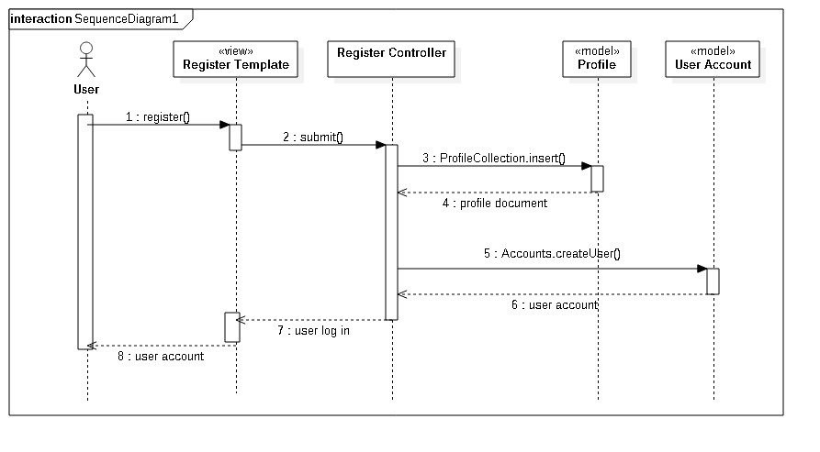

## Class Diagram

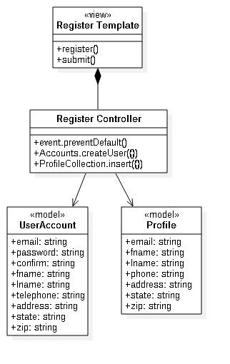

# User Story #747: Sell a Car

* **Description:** As a user I want to be able to sell a car so I can earn money
* **Acceptance Criteria:**

1. In the selling form, the user must enter one picture of the car, the type, the make, the model, the year, the city and the highway MPG, the exterior and interior colors and the mileage.
2. The system must be able to store this information in the appropriate collection and allow it to be retrieved at any moment.

## Use Case: Add Car to Inventory

|  |
| --- |
| **Use Case ID:** CRSUC-07-Sell |
| **Details:** After logging in to the system,user fills the selling form   |  | | --- | | **Actors:** Registered user | | **Pre-conditions:**   1. System login web page has been activated and is displayed. 2. User has an account on the system. 3. User is logged into the system. | | **Description:**   |  | | --- | | 1. Use case begins when user chooses clicks on the sell tab. 2. The system displays a data entry form. 3. The user should enter the following data: a picture of the car, year, make, type, model, mileage, city mpg, highway mpg, engine, exterior color, interior color. 4. After completing the form, the user should click on the “Sell this car” button. 5. Once the system validates the information, the data will be stored in a collection. 6. Use case ends when web page is refreshed. | | | | | | | | **Post-conditions:**   1. The server and application are up and running. 2. User is logged into the system. | |
| **Alternative Course of Action:**   |  | | --- | | 1. User has the option to cancel an addition to his car inventory by going back to the previous page or by closing the browser. | |
| **Exceptions:**   |  | | --- | | 1. The user enters mismatched data type, e.g. numbers where text is expected. 2. The user fails to complete all form fields. | |
| **Related Use Cases:** None |
| **Decisions Report:**   |  | | --- | | **Frequency:** Any number of cars can be created every day. | | **Critically:** High. Users have to create accounts in the system so that they can access the selling form. | | **Risk:** Low. Implementing this use case employs standard web-based and database technology. | |
| **Modification History:**   |  | | --- | | **Owner:** Brenda Izquierdo | | **Initiation date:** 02/01/2016 | | **Date last modified:** 02/12/2016 | |

## Use Case Diagram

## https://lh5.googleusercontent.com/oh7TayscBK7abYliqiLu0bKN87dP7n30DT2MTHCa-jI4z2CSu0IAG8RB_ajDW9nBAvMxV9qqEp0jKMip3NUWuGsb1o36_bEOTaMmyp44O0P31NmozcTd5h4FYbccC-mxdtCXTX-NdDcG22upDg

## Sequence Diagram

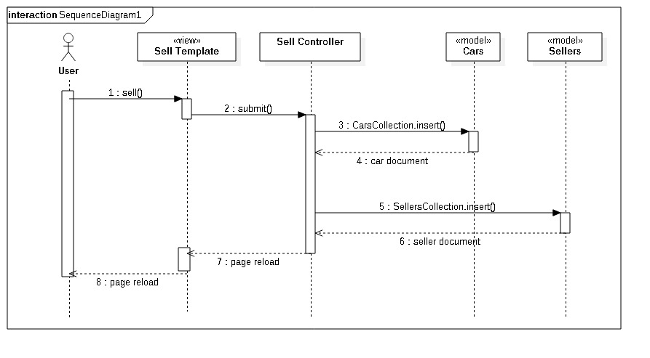

## Class Diagram

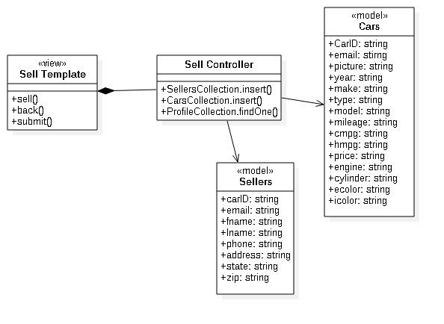

# User Story #749: Reset Password

* **Description:** As a  user I want to be able to be able to reset my user account password in case I forget it so I can log in to the system
* **Acceptance Criteria**

1. User must not be logged in
2. User needs to know his/her user account email

## Use Case: Allow User to Reset Account Password

|  |
| --- |
| **Use Case ID:** CRSUC-12-ResetPassword |
| **Details:** Before being logged into the system, user clicks on “Forgot your password?”   |  | | --- | | **Actors:** Registered User | | **Pre-conditions:**   1. The server is up and running 2. System login web page has been activated and is displayed. | | **Description:**   |  | | --- | | 1. Use case begins when user clicks on the “Forgot your password?” button 2. User enters account email 3. User checks email inbox and clicks on the reset password link 4. User enters new password 5. User is immediately logged in and password is updated | | | | | | | | **Post-conditions:**   1. User account password is updated | |
| **Alternative Course of Action:**   |  | | --- | | 1. User does not remember account email 2. Wrong email is entered 3. User does not click on reset password link | |
| **Exceptions:**   |  | | --- | | 1. None | |
| **Related Use Cases:** CRSUC-11-ChangePassword |
| **Decisions Report:**   |  | | --- | | **Frequency:** Password reset can be performed at any time. | | **Critically:** High. Users need to be able to change their passwords for security reasons. | | **Risk:** Low. Implementing this use case employs standard web-based and database technology. | |
| **Modification History:**   |  | | --- | | **Owner:** Brenda Izquierdo | | **Initiation date:** 03/31/2016 | | **Date last modified:** 04/03/2016 | |

## Use Case Diagram

## https://lh5.googleusercontent.com/_pWuCW31gcAcFC4-Wd85woMxK7tdfyKKeJoejWbM3piJuwSyQ1lwVK3d4LHPWumX5YTp55DsS7Yt3y7qAFpnklbVKwmyWV8qNpc7oczzjkBrj87n1i3M7hY9QA4FS8Eu2TcEeEeX8uOP5XH52w

## Sequence Diagram

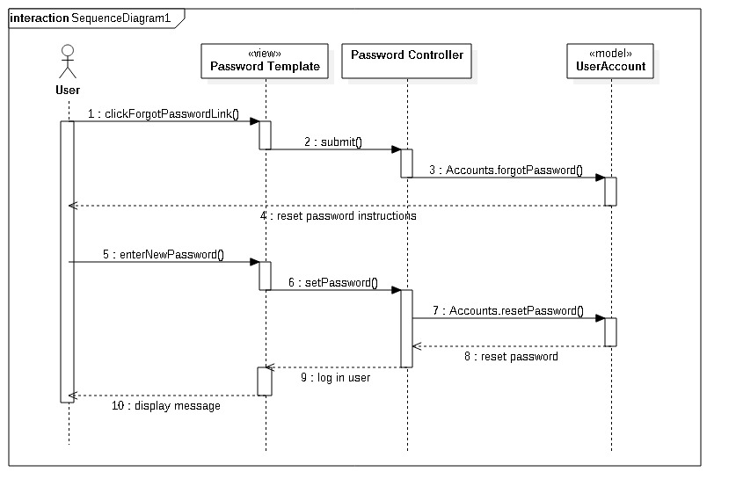

## Class Diagram

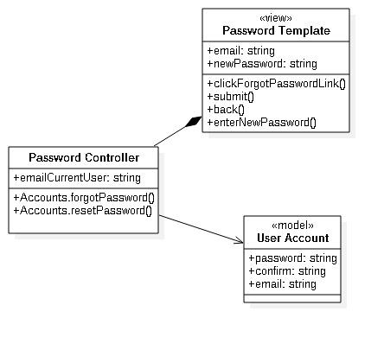

# User Story #803: Update Profile Information

* **Description:** As a user I want to be able to update my personal data so I can have my current personal information in the system
* **Acceptance Criteria:**

1. User must be able to update/change data at any time
2. User does not need to register again to make any changes
3. User can choose to update/change any field and that field only

## Use Case: Update User Profile Information

|  |
| --- |
| **Use Case ID:** CRSUC-11-UpdateProfile |
| **Details:** After logging in to the system,user clicks on the profile tab   |  | | --- | | **Actors:** Registered user | | **Pre-conditions:**   1. System login web page has been activated and is displayed. 2. User is logged in to the system with valid credentials. | | **Description:**   |  | | --- | | 1. Use case begins when user chooses clicks on the profile tab. 2. The system displays the user’s personal information (name, address, state, zip, phone) provided by the user itself during registration. 3. Password is not displayed. 4. User clicks on the Update button. 5. User is taken to the update form. 6. Use case ends when user submits the update form, clicks another tab, or closes the browser. | | | | | | | | **Post-conditions:**   1. User data is updated, upon clicking the button Back, the user can return to the Profile view. 2. User can see his personal information displayed in the profile tab at any time. | |
| **Alternative Course of Action:**   |  | | --- | | 1. User does not submit the update form. 2. User clicks on another tab rather than the profile tab. 3. User closes the browser before accessing the profile tab. | |
| **Exceptions:**   |  | | --- | | 1. None | |
| **Related Use Cases:** CRSUC-09-Profile |
| **Decisions Report:**   |  | | --- | | **Frequency:** Profile data can be updated at any time of the day. | | **Critically:** Medium. Users should be able to update their data as they see fit. | | **Risk:** Low. Implementing this use case employs standard web-based and database technology. | |
| **Modification History:**   |  | | --- | | **Owner:** Brenda Izquierdo | | **Initiation date:** 02/22/2016 | | **Date last modified:** 02/27/2016 | |

## Use Case Diagram

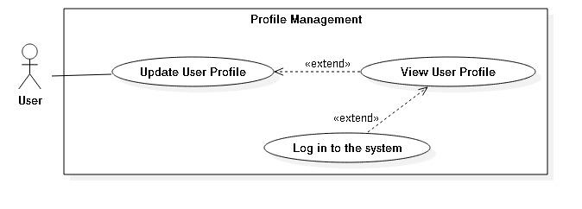

## Sequence Diagram

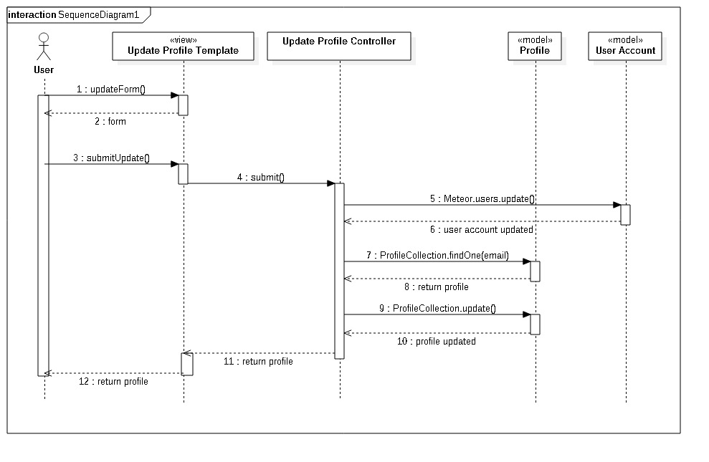

## Class Diagram

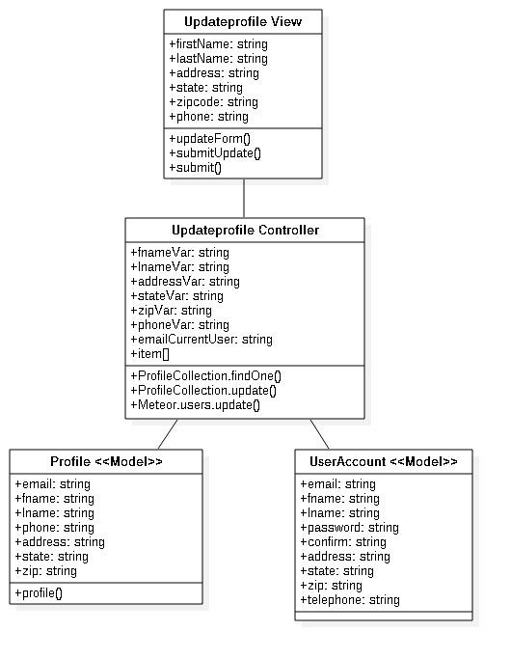

# User Story #804: Update Car Information

* **Description:** As a registered user I want to be able to update the information of any car that I am selling so that possible buyers can access up-to-date data
* **Acceptance Criteria:**

1. User must be able to update/change data at any time
2. User does not need to fill the selling form again to store new changes
3. User can choose to update/change any field and that field only

## Use Case: Manage Car Inventory

|  |
| --- |
| **Use Case ID:** CRSUC-12-UpdateCarInformation |
| **Details:** After logging in to the system,user clicks on the inventory tab   |  | | --- | | **Actors:** Registered user | | **Pre-conditions:**   1. System login web page has been activated and is displayed. 2. User is logged in to the system with valid credentials. | | **Description:**   |  | | --- | | 1. Use case begins when user clicks on the inventory tab. 2. The system displays the user’s car inventory (year, make, model, price, mileage, etc. for each car) provided by the user through the sell form. 3. User clicks on the “Update” button that is in every car list. 4. User is taken to the update form. 5. User updates car data. 6. Use case ends when user submits the updated form, clicks another tab, or closes the browser. | | | | | | | | **Post-conditions:**   1. Car data is updated, upon clicking the button “Back” user can return to the inventory view. 2. User can see the updated car information in the inventory tab. | |
| **Alternative Course of Action:**   |  | | --- | | 1. User does not submit the update form. 2. User clicks on another tab rather than the inventory tab. 3. User closes the browser before accessing the inventory tab. | |
| **Exceptions:**   |  | | --- | | 1. None | |
| **Related Use Cases:** CRSUC-10-Inventory |
| **Decisions Report:**   |  | | --- | | **Frequency:** Inventory data can be updated at any time of the day. | | **Critically:** Medium. Users should be able to update their inventory as they see fit. | | **Risk:** Low. Implementing this use case employs standard web-based and database technology. | |
| **Modification History:**   |  | | --- | | **Owner:** Brenda Izquierdo | | **Initiation date:** 03/02/2016 | | **Date last modified:** 03/05/2016 | |

## Use Case Diagram

## https://lh3.googleusercontent.com/rV2ono5dUV0D-7IwXAKhrUiM747N4TxThrDj3kuZwswY8xzsLQDZdD1M3WKJGHnjIZFmkVIbOfNSz5u7KcaGlZl3a0BEgTvBc8byjLvnU_dfwYV0nDx9RX3nGnXpXqEnz4gGj30LhgRk9_vQ0g

## Sequence Diagram

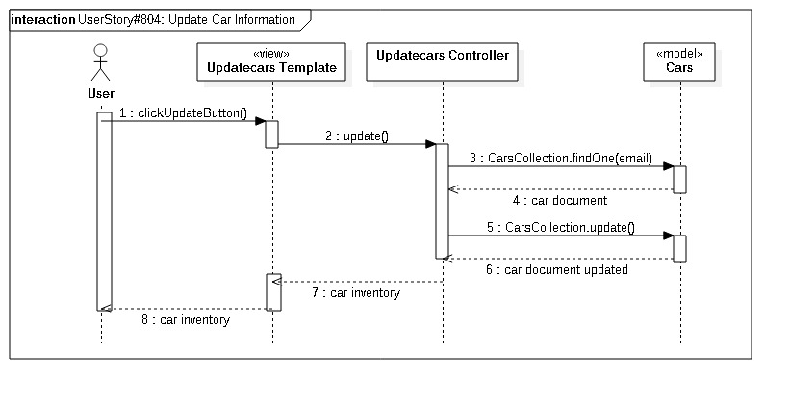

## Class Diagram

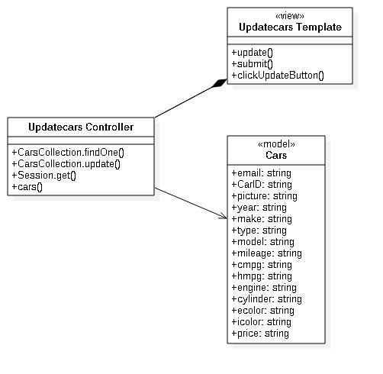

# User Story #817: Display User Profile

* **Description:** As a registered user, I want to be able to see my profile information so I can keep track of my personal data in the system
* **Acceptance Criteria:**

1. User needs to be logged into the system to able to see their personal information
2. Data must be displayed in the Profile tab
3. User password must be displayed

## Use Case: Allow User to See Profile Information

|  |
| --- |
| **Use Case ID:** CRSUC-09-Profile |
| **Details:** After logging in to the system,user clicks on the profile tab   |  | | --- | | **Actors:** Registered user | | **Pre-conditions:**   1. System login web page has been activated and is displayed. 2. User is logged in to the system with valid credentials. | | **Description:**   |  | | --- | | 1. Use case begins when user clicks on the profile tab. 2. The system displays the user’s personal information (name, address, state, zip, phone) provided by the user itself during registration. 3. Password is not displayed. 4. Use case ends when user clicks on another tab. | | | | | | | | **Post-conditions:**   1. User can see his personal information displayed in the profile tab at any time. | |
| **Alternative Course of Action:**   |  | | --- | | 1. User clicks on another tab rather than the profile tab. 2. User closes the browser before accessing the profile tab. 3. No data is displayed on the profile tab | |
| **Exceptions:**   |  | | --- | | 1. None | |
| **Related Use Cases:** CRSUC-10-Inventory |
| **Decisions Report:**   |  | | --- | | **Frequency:** Profile data can be accessed at any time of the day. | | **Critically:** Medium. Users need to be able to see their personal data so they can update it. | | **Risk:** Low. Implementing this use case employs standard web-based and database technology. | |
| **Modification History:**   |  | | --- | | **Owner:** Brenda Izquierdo | | **Initiation date:** 02/15/2016 | | **Date last modified:** 02/23/2016 | |

## Use Case Diagram

## https://lh5.googleusercontent.com/uprzaAsfWFzgQLb8U0BAbXVsKB_89qcsyYw6_Mt7vD4BeG48kwuibZT3hk07CWcgQj9zV6LqqYGD36h2Oo-7DZMlQljFE1DEfWUsFTvL6-KINjyvWwrdMc3oJtEqCzYxGGYeDWPtZ_UPHJEBeQ

## Sequence Diagram

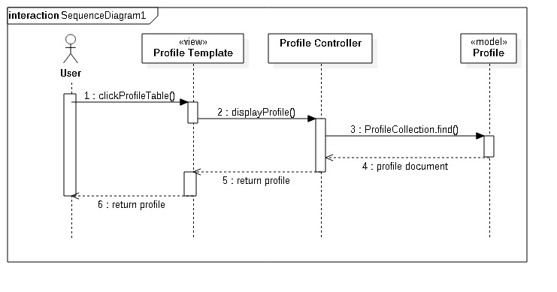

## Class Diagram

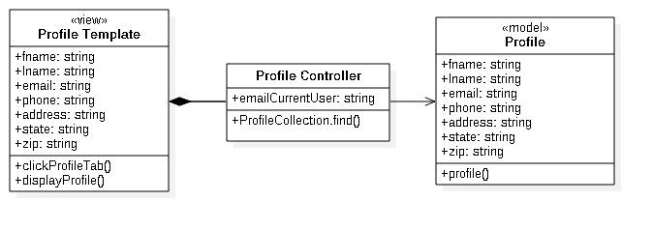

# User Story #818: Display Car Inventory

* **Description:** As a registered user, I want to be able to see all the cars that I am selling so I can manage my inventory
* **Acceptance Criteria:**

1. User must be logged in with valid credentials
2. User must have successfully completed the selling form when attempting to add a car for sale
3. The car inventory should only be displayed in the Inventory tab

## Use Case: Allow User to See Car Inventory

|  |
| --- |
| **Use Case ID:** CRSUC-10-Inventory |
| **Details:** After logging in to the system,user clicks on the Inventory tab   |  | | --- | | **Actors:** Registered user | | **Pre-conditions:**   1. System login web page has been activated and is displayed. 2. User is logged in to the system with valid credentials. | | **Description:**   |  | | --- | | 1. Use case begins when user clicks on the Inventory tab. 2. The system displays the list of cars that were put to sale by the user. 3. For every car, there is the year, make, model, engine, color, mileage and the other properties that were entered through the selling form. 4. Use case ends when user clicks another tabor closes the browser. | | | | | | | | **Post-conditions:**   1. User can see the list of cars he/she is selling in the inventory tab at any time. | |
| **Alternative Course of Action:**   |  | | --- | | 1. User clicks on another tab rather than the inventory tab. 2. User closes the browser before accessing the inventory tab. | |
| **Exceptions:**   |  | | --- | | 1. None | |
| **Related Use Cases:** CRSUC-12-UpdateCarInformation |
| **Decisions Report:**   |  | | --- | | **Frequency:** Inventory data can be accessed at any time of the day. | | **Critically:** Medium. Users need to be able to see their inventories so they can update them. | | **Risk:** Low. Implementing this use case employs standard web-based and database technology. | |
| **Modification History:**   |  | | --- | | **Owner:** Brenda Izquierdo | | **Initiation date:** 02/19/2016 | | **Date last modified:** 02/26/2016 | |

## Use Case Diagram

## https://lh6.googleusercontent.com/HehHzGEne6FyuQVk9PJtPGk7-Z63UM0prCZkdDdzPKPRZAQzWl-Je66mb21-uDZvSZEP5P8WBnU19F3u55F18RzE_dccHVIGdpGB5Pf4oAoKo786VUz4N4Xrjsvmx3hWsFw-O8Ko_3ZwnUTW_A

## Sequence Diagram

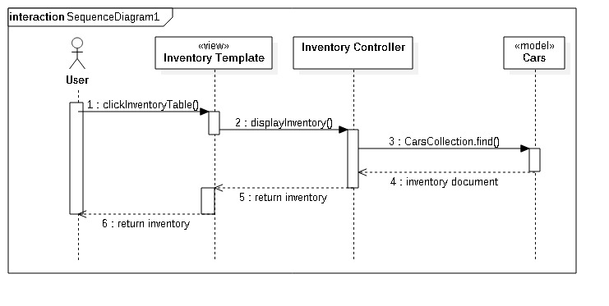

## Class Diagram

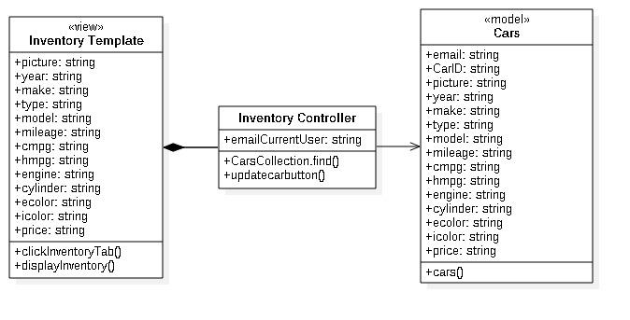

# User Story #846: Connect to an External Database through an API

* **Description:** As a seller I want to be able to extract all the attributes of a car based on a few key ones so I do not have to enter each of them manually
* **Acceptance Criteria:**

1. User needs to have an account
2. User has to be logged in to the system
3. User needs to select the five key attributes manually (make, model, year, style, and color)

## Use Case: Extract Car Data from an External Database

|  |
| --- |
| **Use Case ID:** CRSUC-15-ExternalDatabase |
| **Details:** After logging in to the system,user fills the selling form, this time the form will only offer options to the user rather than request input   |  | | --- | | **Actors:** Registered User | | **Pre-conditions:**   1. System login web page has been activated and is displayed. 2. User has an account on the system. 3. User is logged into the system. | | **Description:**   |  | | --- | | 1. Use case begins when user chooses clicks on the sell tab. 2. The system displays a data entry form. 3. The user should enter the following data: a picture of the car, mileage, and price and select an option from the following dropdown menus: make, model, year, style, and color. 4. After completing the form, the user should click on the “Sell Car” button. 5. Once the system validates the information, the data will be stored in the Cars collection as a document. 6. The new car is stored in the Inventory tab 7. User can click the “Update” “See Details” or “Delete” 8. Use case ends when user is done seeing the car or updating it. | | | | | | | | **Post-conditions:**   1. A new car was added to the Cars Collection 2. The new car is displayed in the Inventory | |
| **Alternative Course of Action:**   |  | | --- | | 1. User has the option to cancel an addition to his car inventory by going back to the previous page or by closing the browser. | |
| **Exceptions:**   |  | | --- | | 1. The user enters mismatched data type, e.g. letters when numeric characters are expected. 2. The user fails to complete all form fields. | |
| **Related Use Cases:** None |
| **Decisions Report:**   |  | | --- | | **Frequency:** Any number of cars can be created every day. | | **Critically:** High. Users have to create accounts in the system so that they can access the selling form. | | **Risk:** Low. Implementing this use case employs standard web-based and database technology. | |
| **Modification History:**   |  | | --- | | **Owner:** Brenda Izquierdo | | **Initiation date:** 02/25/2016 | | **Date last modified:** 03/04/2016 | |

## Use Case Diagram

## https://lh3.googleusercontent.com/eXMkYrsJtUVvCGbU63jZQBt9OaQ1_DdUiX3bTpLxIcPbZUDcHtHSFgjBSGKWlxhRwymXyXnkS_s08i-u5JIiP5pduA6icV-jFKW1HR7k9K_vM4v8BqWiXokfSazhe_Mv222l6MUQjmcPy8xz_Q

## Sequence Diagram

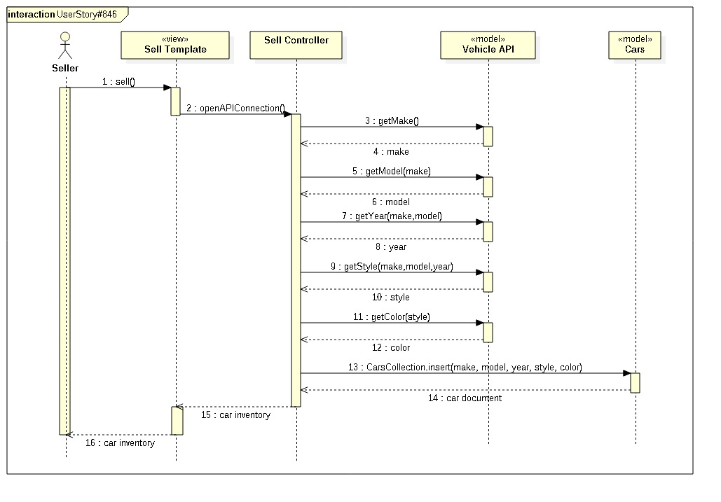

## Class Diagram

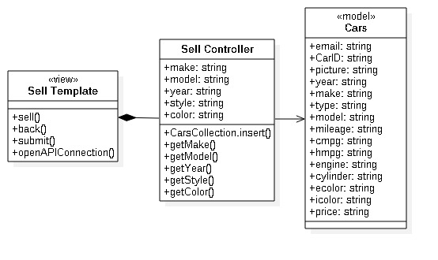

# User Story #852: Contact Seller

* **Description:** As a user I want to be able to contact a seller so I can request further information on a car
* **Acceptance Criteria:**

1. User needs to have an account
2. User must be logged in
3. User must have verified his/her account

## Use Case: Send Email to Seller from the Website

|  |
| --- |
| **Use Case ID:** CRSUC-21-ContactSeller |
| **Details:** After logging in to the system,user chooses a car to ask for more information, he clicks on the “contact seller” link in the slideshow or in the “send email to seller” button in the homelayout   |  | | --- | | **Actors:** Registered User | | **Pre-conditions:**   1. System login web page has been activated and is displayed. 2. User has an account on the system. 3. User is logged into the system. 4. User account is verified | | **Description:**   |  | | --- | | 1. Use case begins when user is on the Home tab. 2. The system displays a car slideshow along with a list further down. 3. The user should observe all cars for sale and pick one that is appealing. 4. If user is on the slideshow, he/she clicks on the red button and on the “Contact Seller” link. If user is in the homelayout list, he/she clicks on the “Send Email to Seller” button. 5. User is taken to another view where a form is displayed. 6. User name, email, phone number, and a template message appear in the form. User can make any changes. 7. User clicks the “Send” button in order to send an email to the seller 8. Use case ends when a popup message appears informing the user that his request has been sent. | | | | | | | | **Post-conditions:**   1. Seller receives the email from the user. 2. User receives a confirmation receipt to his/her inbox. 3. User is back in the Home page. | |
| **Alternative Course of Action:**   |  | | --- | | 1. User has the option to cancel by going back to the previous page or by simply not clicking neither the link nor button. | |
| **Exceptions:**   |  | | --- | | 1. User is not connected to internet. 2. User has not verified the account. 3. Server failure. | |
| **Related Use Cases:** None |
| **Decisions Report:**   |  | | --- | | **Frequency:** Up to 3000 emails can be send every day. | | **Critically:** Low. Users are able to see the seller’s email, thus they can send them an email through their inbox directly. | | **Risk:** Low. Implementing this use case employs standard web-based and database technology. | |
| **Modification History:**   |  | | --- | | **Owner:** Brenda Izquierdo | | **Initiation date:** 04/11/2016 | | **Date last modified:** 04/18/2016 | |

## Use Case Diagram

## 

## Sequence Diagram

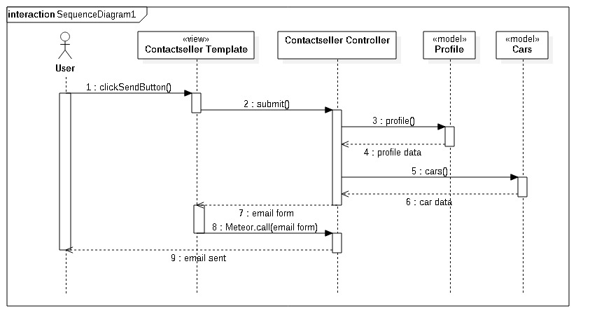

## Class Diagram

­­­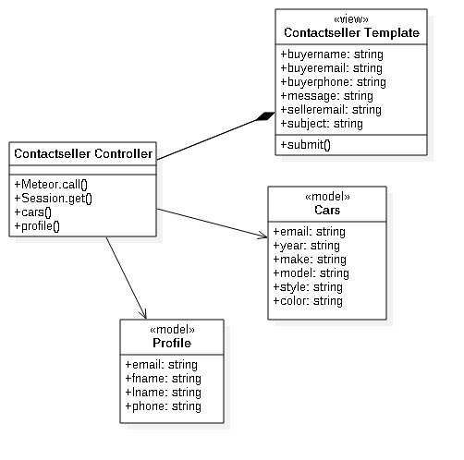

## Pending User Stories

* **Reliable Production Server**
  + Free Meteor servers are great for staging and testing. However, they are slow, spotty, and sometimes down. A production server like AWS would be a great solution.
* **Search a Car**
  + A user should be able to search for a car

# Project Plan

The project plan is the overall planning and overview of how the project built and composed. As typical to agile development each day the team met and planned for the next day and reviewed the day in terms of results and implementations. And in the end of each two weeks we had a team/sprint review of what has been done during the last two weeks. The feedback enabled the team to make the proper and relevant changes so that it’s match the product owner expectation. Each team member evaluated himself as well the other teammate to provide better team efficiency and orientation. The following paragraph describes exactly this methodology that we had followed. It’s describes the milestones and the crucial component of our project as it’s build ups (from sprint to sprint). It’s includes the building stones of our system such as packages and libraries that our system use extensively. and the planning details and specification of each sprint and user stories for each sprint as it span throughout the sprint duration.

## Hardware and Software Resources

DEVELOPMENT PLATFORM

* Meteor
  + Provides full stack capabilities to develop a mobile application or website with focus on reactive changes and developmental flexibility.
  + HTML5, CSS, JavaScript

HOSTING

* Staging: Car Recommendation System-fiu.meteor.com
  + Using Meteor.com’s free hosting service.
  + Used to allow anyone to see the working application without installing it on their phones.
* Admin Portal:

SUPPORTED OPERATING SYSTEMS

* Android + iOS
  + Meteor allows for fast deployment of applications to Android and iOS devices.
  + Other operating systems not in focus due to testing and UI constraints.
* Web Browser
  + FOR TESTING AND SHOWCASING PURPOSES ONLY.

METEOR PACKAGES

* meteor-platform
  + Standard Meteor pre-installed package
* insecure
  + Allow almost all collection methods, such as insert, update, and remove, to be called from the client.
* jquery
  + A javascript library designed to simplify javascript writing.
* iron:router
  + A page router that works on the server and the client.
* http
  + Allows application to make http calls to remote servers.
* sacha:spin
  + Spinner package for loading times.
* mdg:geolocation
  + Provides reactive geolocation on any device.
* meteorhacks:npm
  + Use npm modules with a Meteor app.
* accounts-password
  + A login service that enables secure password-based login
* accounts-ui
  + Simple template to add login widgets to an app.
* accounts-twitter
  + Login service for Twitter accounts
* twbs:bootstrap
  + Popular front-end framework for developing responsive, mobile-first projects.
* accounts-facebook
  + Login service for Facebook accounts.
* aldeed-Collection2
  + Automatic validation of insert and update operations on the client and server.
* aldeed-autoform
  + Takes your collection's schema and automatically create HTML5 forms based on it.
* steeve:jsignature
  + jSignature is a jQuery plugin which simplifies creation of a signature capture field in the browser window, allowing a user to draw a signature using mouse, pen, or finger.
* meteorhacks:subs-manager
  + a general-purpose subscriptions manager for Meteor. It also works pretty well with [Iron Router](https://github.com/EventedMind/iron-router), with some limitations.
* meteorhacks:ssr
  + Server side rendering for Meteor with Blaze.
* Navigation-npm
* SVM-npm
* Distance-npm
* dfischer:phantomjs
  + A scripted, [headless browser](https://en.wikipedia.org/wiki/Headless_browser) used for automating web page interaction.

## Sprints Plan

For each sprint, list the user stories selected for implementation in descending order of priority.

Sprint 0

**User Story # - Frameworks and Languages Tutorial**

***Tasks***

* Learn Javascript (Brenda and Zeev)
* Learn MongoDB (Brenda and Zeev)
* Learn Meteor (Brenda and Zeev)

***Acceptance Criteria***

* Javascript tutorial complete
* MongoDB tutorial complete
* Meteor tutorial complete

***Modeling***

Refer to UML diagrams in Appendix A that were created or modified to model the functionality that will be implemented in this sprint.

Sprint 0,1

Date: 1/15

Attendees: Zeev Feldbeine, Brenda Izquierdo

Start time: 4:00

End time: 4:30

After discussion, the velocity of the team were estimated to be ??.

Around one week for development and one week for documentation.

The product owner chose the following user stories to be done during the next sprint. They are ordered based on their priority.

* User Story #744: Register New User
* User Story #745: User Login
* User Story #748: User Logout

The team members indicated their willingness to work on the following user stories.

* Zeev Feldbeine: User Story #745, #748
* Brenda Izquierdo: User Story #744

Sprint 1

Date: 1/29

Attendees: Zeev Feldbeine, Brenda Izquierdo

Start time: 9:00am

End time: 11:00am

After discussion, the velocity of the team were estimated to be ??.

Around one week for development and one week for documentation.

The product owner chose the following user stories to be done during the next sprint. They are ordered based on their priority.

* User Story #747: Sell a Car
* User Story #802: Display Car Information
* User Story #752: Display Cars

The team members indicated their willingness to work on the following user stories.

* Zeev Feldbeine: User Story #752, #802
* Brenda Izquierdo: User Story #747

Sprint 2

Date: 02/12

Attendees: Zeev Feldbeine, Brenda Izquierdo

Start time: 9:00am

End time: 11:00am

After discussion, the velocity of the team were estimated to be ??.

Around one week for development and one week for documentation.

The product owner chose the following user stories to be done during the next sprint. They are ordered based on their priority.

* User Story #750: Car Favorites List
* User Story #803: Update Profile Information
* User Story #817: Display User Profile
* User Story #818: Display Car Inventory
* User Story #819: Change Password

The team members indicated their willingness to work on the following user stories.

* Zeev Feldbeine: User Story #750
* Brenda Izquierdo: User Story #803, #817, #818, #819

Sprint 3

Date: 02/26

Attendees: Zeev Feldbeine, Brenda Izquierdo

Start time: 7:30pm

End time: 9:30am

After discussion, the velocity of the team were estimated to be ??.

Around one week for development and one week for documentation.

The product owner chose the following user stories to be done during the next sprint. They are ordered based on their priority.

* User Story #746: Recommendation Algorithm
* User Story #804: Update Car Information
* User Story #836: Distance Recommendation

The team members indicated their willingness to work on the following user stories.

* Zeev Feldbeine: User Story #746, #836
* Brenda Izquierdo: User Story #804

Sprint 4

Date: 03/11

Attendees: Zeev Feldbeine, Brenda Izquierdo

Start time: 7:30pm

End time: 9:30am

After discussion, the velocity of the team were estimated to be?

Around one week for development and one week for documentation.

The product owner chose the following user stories to be done during the next sprint. They are ordered based on their priority.

* User Story #749: Reset Password
* User Story #837: List View
* User Story #838: Google Maps
* User Story #846: Connect to an External Database through an API call

The team members indicated their willingness to work on the following user stories.

* Zeev Feldbeine: User Story #837, #838
* Brenda Izquierdo: User Story #749, #846

Sprint 5

Date: 04/01

Attendees: Zeev Feldbeine, Brenda Izquierdo

Start time: 11:30pm

End time: 1pm

After discussion, the velocity of the team were estimated to be:

Around one week for development and one week for documentation.

The product owner chose the following user stories to be done during the next sprint. They are ordered based on their priority.

* User Story #850 - Setting Virtual Machine
* User Story #853 - Code Refactoring/Security
* User Story #852 - Contact Seller

The team members indicated their willingness to work on the following user stories.

* Zeev Feldbeine: User Story #850, #853
* Brenda Izquierdo: User Story #852

Sprint 6

Date: 04/15

Attendees: Zeev Feldbeine, Brenda Izquierdo

Start time: 11:30pm

End time: 1pm

After discussion, the velocity of the team were estimated to be:

Around one week for development and one week for documentation.

The product owner chose the following user stories to be done during the next sprint. They are ordered based on their priority.

* User Story #851: Search a Car

The team members indicated their willingness to work on the following user stories.

* Zeev Feldbeine: User Story #851

# System Design

This section discuss the architecture pattern of the system and its subsystem decomposition. The section makes up the complete description from the bottom up to how the system should behave and interact with the other subsystems. In terms of Architectural patterns, MVC describes perfectly the design and behavior of the system as discussed and described in great details in the next paragraph. The System and Subsystem decomposition describes the subsystems that make our system as a whole, and their interaction with other subsystems. This paragraph is complete breakthrough of the system in terms of its functionality and work. In addition the paragraph also describe and depicts the different relations among the subsystems and their interaction. The General System design of the application is what called “isomorphic JavaScript” and can also be described as single-page app.

## Hardware and Software Mapping

Car Recommendation System is a 3-part system. The primary portion is the Client side, which is in the form of web application only with what is meant for the user to see (Client Files). It is accompanied by the central server that holds the primary database (MongoDB) and server logic (Server Files).

## Architectural Patterns

The system is an instance of isomorphic JavaScript application, or in other words is the hybrid between the server side and the client side to create a single page app. That is communicated and works both in the client-side and server-side using the same algorithm and code.

Therefore the architecture pattern stay the same as regular client, server application. Though, this is special kind of MVC as depicted in the following figure: as Client, Infrastructure, and Services

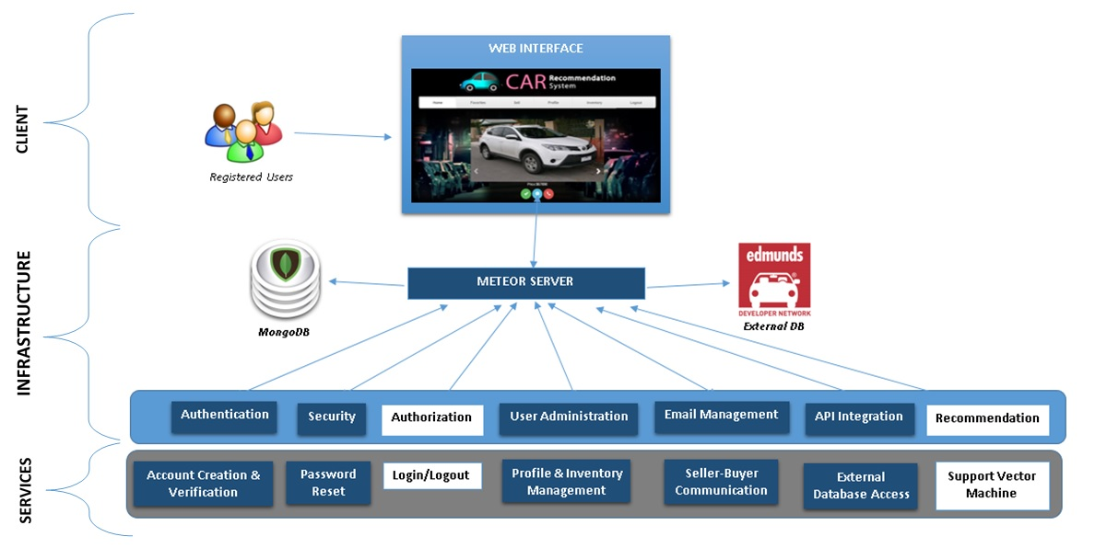

**Figure 1.17** - description of the client, server side.

The architecture pattern we identified is MVC (or Client-server MVC). Because there is JavaScript running both on the server side and the client, and described as one layer, similarly to the client-serve MVC architecture. Therefore the application and the view logic can run both on the server and the client side. In addition the nature of Meteor.js describes the Model as MongoDB that is interconnected with the server and the client-side (“MiniMongo”).

As can be seen in the figure 1.01 the MiniMongo resides in the client browser, while the MongoDB resides in the server sides and contains full details and information of the data. Therefore using the nature of Meteor.js it’s naturally fit to this description when describing one system doing both the view, control and model that are interconnected between the server side and client side using JavaScript.

## 

## System and Subsystem Decomposition



**Figure 1.18** - Package diagram

* Persistent data - the model layer of the system. It’s includes the MongoDB that resides on the server side and the MiniMongo that resides on the client/browser side. The subsystem Responsible for creating, retrieving, updating and manipulate records from the database. The jobs is accomplished by Meteor.js packages and architecture.
* User Interface - the view layer of the system. This layer consists with subsystems responsible for interacting with the user views.
* Home UI - shows the available views to the user. In JavaScript terms it’s called routing, that also deals with the permission and the related pages available to the user.
* Recomandation UI - the Recommendation administrator, shows the views available Cars based on user favorites. It also provides the services and information of the user.
* Map UI - shows the available maps and distance to the user, it also included the registration and selling cars and user inventory
* Controller- the control layer of the system. This layer consists with subsystems responsible for the logic and controlling the subsystems of the views layer.
* Home Controller - is the main controlling subsystem that is responsible for the routing and permission for different pages and services.
* Recommand Controller - the recommand controller is responsible for receiving data from the database and the UI subsystem. It the main logic for the user based on favorites and SVM and navigation algorithms
* Distance Controller - the distance controller is responsible for receiving data and using the google api of map and different libraries to calculate the distance between users

## Deployment Diagram

The following figure describes the deployment diagram and the classes each one consists.

It following the MVC architecture pattern with View, Model and Controller. They follows the general subsystems of the package diagram. In the view layer the system consists of the pages and views displayed to the client/user. The model layer uses MongoDB on the server side and MiniMongo on the client side. And the controller layer is responsible for the rounting and the logic(it also includes the reactivity feature of meteor.js).

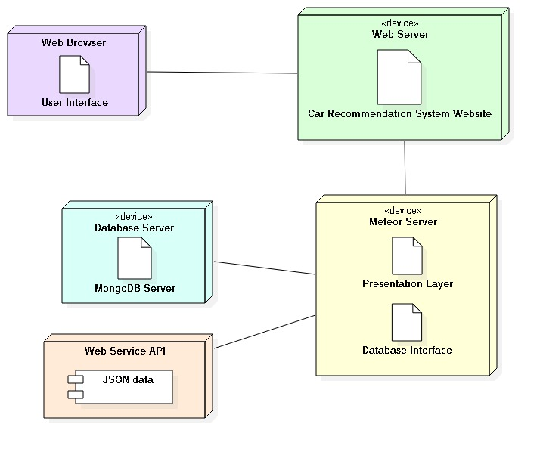

**Figure 1.19** - Deployment Model

## Design Patterns

As can also be seen from the class diagram the design patterns used in our project Car Recommendation System enabled us to create consistency and common interface of functionality. Therefore, much secures application and easier to understand and follows as it specify a clear object oriented relationships and functionalities. The design patterns that were used on this project are singleton, command and abstract factory.

* Singleton: We used this design patterns mostly for convenience and security, such that there is only one instance of each database entity and other functions require just to use and fetch this only entity. The benefits of doing so are to not create redundancy and confusion, it also enable us to create consistency throughout the code so that each object is inserted to his designated collection instance. Moreover, using this design pattern provide with great security and usability as each function and class can look on the collections as one interface and instance.
* Command: we used this design patterns to create common interface and convenience for commands that are frequently used. Such as set menu and set view, that effect the overall functionality and therefore crucial for making independent interface for the commands. The implementation of set view and menu follows this pattern so each function and class call this common interface/class to set the functionality of the command (from common function).
* Abstract Factory: this design patterns is perhaps the most useful and helpful in our project, since it’s enabled us to implement more easily and faster the chat for each representative and map region chat. It enabled us to create entities more easily and consistent in its design/functionality and implementation. In our project (Car Recommendation System) the abstract factory is designated for creating the chat interface and functionality for the representative and map location. So the chat functionality and characteristics are the same just the context of the chat is different.

# System Validation

This paragraph describes the testing conducted to validate the system and the overall functionality of the system and the subsystems. The following user stories were tested using selenium, therefore this section also includes the code used to make the testing of each functionality and user story. This paragraph includes the test cases of each testing conducted for user story. The following test cases were first analyzed and then tested using automated testing (selenium) and manual testing, and compared to the expected result and actual result to check the matching and validation.

## Unit Test #744

|  |  |
| --- | --- |
| Test Case ID | CRS_UT_RegisterAttempt_01 (Sunny Day) |
| Purpose | Verify that the registration link is in functional mode |
| Preconditions | * The server and application are up and running * User does not have an account on the system |
| Input | * User clicks on the “Don't have an account yet? Register for free” link in the login page |
| Expected Output | User is taken directly to the registration page |

|  |  |
| --- | --- |
| Test Case ID | CRS_UT_RegisterAttempt_02 (Sunny Day) |
| Purpose | Verify that user is not prevented from entering data of any type in any input field |
| Preconditions | * The server and application are up and running * User does not have an account on the system * Registration form is being displayed |
| Input | * User fills the registration form with the data below * First Name: B#$nd@ * Last Name: !!!! * Email: [bizqu002@fiu.edu](mailto:bizqu002@fiu.edu) * Password: *** * Confirm Password: *** * Address: !@#$%^&* * State: FL * Zip Code: aaaaa * Telephone: 1234567890 |
| Expected Output | * No alerts or messages appear in the form * Data is displayed as it is entered |

|  |  |
| --- | --- |
| Test Case ID | CRS_UT_RegisterAttempt_03 (Sunny Day) |
| Purpose | Verify that user can fill the form input fields at random |
| Preconditions | * The server and application are up and running * User does not have an account on the system * Registration form is being displayed |
| Input | * User fills the registration form with the data below * First Name: Brenda * Last Name: * Email: [bizqu002@fiu.edu](mailto:bizqu002@fiu.edu) * Password: * Confirm Password: * Address: * State: FL * Zip Code: 33165 * Telephone: |
| Expected Output | * User is able to choose the data fields to be filled first * No alerts or messages appear in the form |

|  |  |
| --- | --- |
| Test Case ID | CRS_UT_RegisterAttempt_04(Rainy Day) |
| Purpose | Verify that the confirm password feature does not work before user clicks the Register button |
| Preconditions | * The server and application are up and running * User does not have an account on the system * Registration form is being displayed |
| Input | * User fills the registration form with the data below * First Name: Brenda * Last Name: Izquierdo * Email: [bizqu002@fiu.edu](mailto:bizqu002@fiu.edu) * Password: brenda * Confirm Password: izquierdo * Address: 1820 NW 107TH ST * State: FL * Zip Code: 33165 * Telephone: 5556667777 |
| Expected Output | * No message appears to alert user that passwords do not match |

|  |  |
| --- | --- |
| Test Case ID | CRS_UT_RegisterAttempt_05(Rainy Day) |
| Purpose | Verify that the validate email feature does not work before user clicks on the Register button |
| Preconditions | * The server and application are up and running * User does not have an account on the system * Registration form is being displayed |
| Input | * User fills the registration form with the data below * First Name: Brenda * Last Name: Izquierdo * Email: [bizqu002fiu.edu](mailto:bizqu002@fiu.edu) * Password: brenda * Confirm Password: brenda * Address: 1820 NW 107TH ST * State: FL * Zip Code: 33165 * Telephone: 5556667777 |
| Expected Output | * No message appears to ask the user to modify the email address entry, even though this email address had already been registered |

|  |  |
| --- | --- |
| Test Case ID | CRS_UT_RegisterAttempt_06(Rainy Day) |
| Purpose | Verify that system cannot detect CAPS LOCK in the password input field |
| Preconditions | * The server and application are up and running * User does not have an account on the system * Registration form is being displayed |
| Input | * User fills the password and confirm password fields with CAPS LOCK on * Password: PASSWD * Confirm Password: PASSWD |
| Expected Output | * No message appears to alert user that CAPS LOCK is on |

|  |  |  |
| --- | --- | --- |
| Test Case ID | Purpose | Result |
| CRS_UT_RegisterAttempt_01 | Verify that the registration link is in functional mode | PASS |
| CRS_UT_RegisterAttempt_02 | Verify that user is not prevented from entering data of any type in any input field | PASS |
| CRS_UT_RegisterAttempt_03 | Verify that user can fill the form input fields at random | PASS |
| CRS_UT_RegisterAttempt_04 | Verify that the confirm password feature does not work before user clicks the Register button | PASS |
| CRS_UT_RegisterAttempt_05 | Verify that the validate email feature does not work before user clicks on the Register button | PASS |
| CRS_UT_RegisterAttempt_06 | Verify that system cannot detect CAPS LOCK in the password input field | PASS |

## Integration Test #744

|  |  |
| --- | --- |
| Test Case ID | CRS_IT_RegisterAttempt_01 (Sunny Day) |
| Purpose | Verify that user is taken to the website home page immediately upon registration |
| Preconditions | * The server and application are up and running * User does not have an account on the system * Registration form is being displayed |
| Input | * User fills the registration form with the data below * First Name: Brenda * Last Name: Izquierdo * Email: [brenda.izquierdo@fiu.edu](mailto:bizqu002@fiu.edu) * Password: brenda * Confirm Password: brenda * Address: 1820 NW 107TH ST * State: FL * Zip Code: 33165 * Telephone: 5556667777 * User clicks the Registration button |
| Expected Output | User is taken directly to the website home page |

|  |  |
| --- | --- |
| Test Case ID | CRS_IT_RegisterAttempt_02 (Sunny Day) |
| Purpose | Verify that user cannot register twice with the same email |
| Preconditions | * The server and application are up and running * User does not have an account on the system * Registration form is being displayed |
| Input | * User fills the registration form with the data below * First Name: Brenda * Last Name: Izquierdo * Email: [bizqu002@fiu.edu](mailto:bizqu002@fiu.edu) * Password: brenda * Confirm Password: brenda * Address: 1820 NW 107TH ST * State: FL * Zip Code: 33165 * Telephone: 5556667777 * User clicks the registration button |
| Expected Output | * An “Error: email is already taken” message appears * Registration form is empty and user is expected to begin anew |

|  |  |
| --- | --- |
| Test Case ID | CRS_IT_RegisterAttempt_03 (Rainy Day) |
| Purpose | Verify that users can register even though passwords are mismatched |
| Preconditions | * The server and application are up and running * User does not have an account on the system * Registration form is being displayed |
| Input | * User fills the registration form with the data below * First Name: Brenda * Last Name: Izquierdo * Email: [brenizq@hotmail.com](mailto:bizqu002@fiu.edu) * Password: brenda * Confirm Password: izquierdo * Address: 1820 NW 107TH ST * State: FL * Zip Code: 33165 * Telephone: 5556667777 * User clicks the registration button |
| Expected Output | * “Passwords don’t match” alert message appears at the top of the Confirmation Password input field * User is prevented from registering |

|  |  |
| --- | --- |
| Test Case ID | CRS_IT_RegisterAttempt_04(Rainy Day) |
| Purpose | Verify that the user cannot register with a password that has less than 6 digits |
| Preconditions | * The server and application are up and running * User does not have an account on the system * Registration form is being displayed |
| Input | * User fills the registration form with the data below * First Name: Brenda * Last Name: Izquierdo * Email: [brendaizquierdo92@yahoo.com](mailto:bizqu002@fiu.edu) * Password: bren * Confirm Password: bren * Address: 1820 NW 107TH ST * State: FL * Zip Code: 33165 * Telephone: 5556667777 * User clicks on the Registration button |
| Expected Output | * “Please lengthen this text to 6 characters or more (you are currently using 4 characters)” alert message appears in the Password field * User is prevented from registering |

|  |  |  |
| --- | --- | --- |
| **Test Case ID** | **Purpose** | **Result** |
| **CRS_IT_RegisterAttempt_01** | Verify that user is taken to the website home page immediately upon registration | PASS |
| **CRS_IT_RegisterAttempt_02** | Verify that user cannot register twice with the same email | PASS |
| **CRS_IT_RegisterAttempt_03** | Verify that users can register even though passwords are mismatched | PASS |
| **CRS_IT_RegisterAttempt_04** | Verify that the user cannot register with a password that has less than 6 digits | PASS |

## 

## Unit Test #745

|  |  |
| --- | --- |
| Test Case ID | Login_01(Sunny Day) |
| Purpose | Determine if an existing user can successfully login to the system, assuming the user profile exists in the database already. |
| Test Setup | Navigate to the login and registration page  and enter input |
| Input Values | Email: [zeev@zeev.com](mailto:zeev@zeev.com)  Password: 123456 |
| Expected Output | User is logged in successfully and directed to the login page |

|  |  |
| --- | --- |
| Test Case ID | Login_02(Rainy Day) |
| Purpose | Verify that the system can handle a user refreshing and then attempting to log in again, assuming user profile exists in the database. |
| Test Setup | Navigate to the login and registration page  and enter input |
| Input Values | Email:zeev@zeev.com  Password: 123456 |
| Expected Output | User is logged in successfully and directed to the login page |

|  |  |
| --- | --- |
| Test Case ID | LogIn03(Rainy Day) |
| Purpose | Verify that submit empty login in will fail |
| Test Setup | Navigate to the login and registration page  etner empty input |
| Input Values | Email: “”  Password: “” |
| Expected Output | User is logged in unsuccessfully and directed to login page |

|  |  |
| --- | --- |
| Test Case ID | LogIn04(Rainy Day) |
| Purpose | Verify that the system will block incorrect user account |
| Test Setup | Navigate to the login and registration page |
| Input Values | Email: zeeeeeeeeeeeev@zeev.com  Password: 1222222222223456 |
| Expected Output | User is logged in unsuccessfully and directed to login page |

|  |  |
| --- | --- |
| Test Case ID | LogIn05(Rainy Day) |
| Purpose | Verify that the system will store user session |
| Test Setup | Navigate to the login and registration page  enter the user input  click refresh or return back to login page |
| Input Values | Email: zeev@zeev.com  Password: 123456 |
| Expected Output | User is logged in and cannot return back to the login or registration page |

Result:

|  |  |  |
| --- | --- | --- |
| #test | succeed | failed |
| test1 | YES |  |
| test2 | YES |  |
| test3 | YES |  |
| test4 | YES |  |
| test5 | YES |  |

## Integration Test

|  |  |
| --- | --- |
| Test Case ID | LoginIntegration_01(Sunny Day) |
| Purpose | Determine if an existing user can successfully login to the system, and log out. |
| Test Setup | Navigate to the login page  and enter existing account and  log out immediately after |
| Input Values | Email: [zeev@zeev.com](mailto:zeev@zeev.com)  Password: 123456  logout click |
| Expected Output | User is logged in successfully and directed to the home page and then log out successfully and and directed to the login page |

|  |  |
| --- | --- |
| Test Case ID | LoginIntegration_02(Rainy Day) |
| Purpose | Determine if an existing user will stay logged in even after clicking back button or moving to registration page |
| Test Setup | Navigate to the login page  and enter existing account and  click the back button or move to the registration page |
| Input Values | Email: [zeev@zeev.com](mailto:zeev@zeev.com)  Password: 123456  back button click |
| Expected Output | User is logged in successfully and is logged in even after clicking on the back button |

|  |  |
| --- | --- |
| Test Case ID | LoginIntegration_03(Sunny Day) |
| Purpose | Determine if a user can login after creating an account |
| Test Setup | Navigate to the registration page  and register with new account  after registration navigate to the login page  and log in with the newly registered account |
| Input Values | Email: [zeev@zeev.com](mailto:zeev@zeev.com)  Password: 123456  back button click |
| Expected Output | User is logged in successfully with the new account |

|  |  |
| --- | --- |
| Test Case ID | LoginIntegration_04(Rainy Day) |
| Purpose | Determine if a user can login after login out with the same account |
| Test Setup | Navigate to the login page,  after logging in click log out  and log in again with the same account |
| Input Values | Email: [zeev@zeev.com](mailto:zeev@zeev.com)  Password: 123456  back button click |
| Expected Output | User is logged in successfully after the log out |

Result:

|  |  |  |
| --- | --- | --- |
| #test | succeed | failed |
| test1 | YES |  |
| test2 | YES |  |
| test3 | YES |  |
| test4 | YES |  |

## Unit Test #747

|  |  |
| --- | --- |
| Test Case ID | CRS_UTS_SellCar_01 (Sunny Day) |
| Purpose | Verify that the selling template is in functional mode |
| Preconditions | * The server and application are up and running * User is logged into the system |
| Input | * User clicks on the Sell tab in the menu bar |
| Expected Output | User is taken directly to the selling form |

|  |  |
| --- | --- |
| Test Case ID | CRS_UT_SellCar_02 (Sunny Day) |
| Purpose | Verify that user is not prevented from entering data of any type in any input field in any order |
| Preconditions | * The server and application are up and running * User is logged into the system * Selling form is being displayed |
| Input | * User fills the selling form with the data below * Year: 2015 * Make: Aston Martin * Type: * Model: * Mileage: mileage * City MPG: city * Highway MPG: highway * Engine: Automatic * Cylinder: * Exterior Color: Black * Interior Color: Black |
| Expected Output | * No alerts or messages appear in the form * Data is displayed as it is entered * User is not required to follow a specific order when entering data |

|  |  |
| --- | --- |
| Test Case ID | CRS_UT_SellCar_03 (Sunny Day) |
| Purpose | Verify that the upload picture functionality works |
| Preconditions | * The server and application are up and running * User is logged into the system * Selling form is currently displayed |
| Input | * User fills the selling form with the data below * Choose File: C:\...\rav4.jpg |
| Expected Output | * Immediately upon selecting the image, the user is able to see a thumbnail of it, e.g. in this case:   rav4.jpg |

|  |  |
| --- | --- |
| Test Case ID | CRS_UT_SellCar_04(Rainy Day) |
| Purpose | Verify that the upload picture functionality stores the path of the image |
| Preconditions | * The server and application are up and running * User is logged into the system * Selling form is currently displayed |
| Input | * User fills the selling form with the data below * Choose File: C:\...\rav4.jpg * Year: 2015 * Make: Toyota * Type: SUV * Model: RAV4 * Mileage: 39500 * City MPG: 24 * Highway MPG: 28 * Engine: Automatic * Cylinder: 4-Cylinder * Exterior Color: White * Interior Color: Black * User clicks on “Sell this car” button |
| Expected Output | * In the Inventory tab the following data is displayed: * Picture: C:\fakepath\rav4.jpg * Year: 2015 * Make: Toyota * Type: SUV * Model: RAV4 * Mileage: 39500 * City MPG: 24 * Highway MPG: 28 * Engine: Automatic * Cylinder: 4-Cylinder * Exterior Color: White * Interior Color: Black * User cannot see the path of the image, because it is coded into a “fakepath” |

|  |  |
| --- | --- |
| Test Case ID | CRS_UT_SellCar_05(Rainy Day) |
| Purpose | Verify that the validate data field features do not work before user clicks on the Sell this car button |
| Preconditions | * The server and application are up and running * User is logged into the system * Selling form is currently displayed |
| Input | * User fills the selling form with the data below * Choose File: C:\...\rav4.jpg * Year: 2015 * Make: Toyota * Type: SUV * Model: rav4 * Mileage: mileage * City MPG: city * Highway MPG: highway * Engine: Automatic * Cylinder: 4-Cylinder * Exterior Color: Black * Interior Color: Black |
| Expected Output | * No message appears to ask the user to modify the year, mileage, city mpg, highway mpg entries, even though they do not conform to the pattern specified |

|  |  |  |
| --- | --- | --- |
| Test Case ID | Purpose | Result |
| CRS_UT_SellCar_01 | Verify that the selling template is in functional mode | PASS |
| CRS_UT_SellCar_02 | Verify that user is not prevented from entering data of any type in any input field in any order | PASS |
| CRS_UT_SellCar_03 | Verify that the upload picture functionality works | PASS |
| CRS_UT_SellCar_04 | Verify that the upload picture functionality stores the path of the image | PASS |
| CRS_UT_SellCar_05 | Verify that the validate data field features do not work before user clicks on the Sell this car button | PASS |

## 

## Integration Test #747

|  |  |
| --- | --- |
| Test Case ID | CRS_IT_SellCar_01 (Sunny Day) |
| Purpose | Verify that user can sell a car |
| Preconditions | * The server and application are up and running * User is logged into the system * Sell form is displayed |
| Input | * User fills the selling form with the data below * Choose File: C:\...\rav4.jpg * Year: 2015 * Make: Toyota * Type: SUV * Model: RAV4 * Mileage: 39500 * City MPG: 24 * Highway MPG: 28 * Engine: Automatic * Cylinder: 4-Cylinder * Exterior Color: White * Interior Color: Black * User clicks on “Sell this car” button |
| Expected Output | * Car data is stored in CarsCollection |

|  |  |
| --- | --- |
| Test Case ID | CRS_IT_SellCar_02 (Sunny Day) |
| Purpose | Verify that a user can sell more than one car |
| Preconditions | * The server and application are up and running * User is logged into the system with the same credentials as in the previous test case * Sell form is displayed |
| Input | * User fills the selling form with the data below * Choose File: C:\...\accord.jpg * Year: 2014 * Make: Honda * Type: Sedan * Model: Accord * Mileage: 12500 * City MPG: 27 * Highway MPG: 32 * Engine: Automatic * Cylinder: 4-Cylinder * Exterior Color: Black * Interior Color: Black * User clicks on “Sell this car” button |
| Expected Output | * Car data is stored in CarsCollection * User goes to Inventory tab and sees the previous car listed for sale as well as this one |

|  |  |
| --- | --- |
| Test Case ID | CRS_IT_SellCar_03 (Rainy Day) |
| Purpose | Verify that user cannot submit illegal/mismatched input |
| Preconditions | * The server and application are up and running * User is logged into the system * Sell form is displayed |
| Input | * User fills the selling form with the data below * Choose File: C:\...\yaris.jpg * Year: 2008 * Make: Toyota * Type: Hatchback * Model: Yaris * Mileage: mileage * City MPG: city * Highway MPG: highway * Engine: Automatic * Cylinder: 2-Cylinder * Exterior Color: Blue * Interior Color: Black * Click on “Sell this car” button |
| Expected Output | * A “Please match the requested format” message appears in the fields that contain invalid data * User is prevented from putting this car for sale |

|  |  |
| --- | --- |
| Test Case ID | CRS_IT_SellAttempt_04(Rainy Day) |
| Purpose | Verify that user cannot submit an incomplete form |
| Preconditions | * The server and application are up and running * User is logged into the system * Sell form is displayed |
| Input | * User fills the selling form with the data below * Choose File: * Year: 2010 * Make: Ferrari * Type: * Model: * Mileage: * City MPG: 18 * Highway MPG: 25 * Engine: Automatic * Cylinder: 4-Cylinder * Exterior Color: Gold * Interior Color: Black * Click on “Sell this car” button |
| Expected Output | * A “Please fill out this field” message appears in the topmost empty field * User is prevented from putting this car for sale |

|  |  |  |
| --- | --- | --- |
| **Test Case ID** | **Purpose** | **Result** |
| CRS_IT_SellCar_01 | Verify that user can sell a car | PASS |
| CRS_IT_SellCar_02 | Verify that a user can sell more than one car | PASS |
| CRS_IT_SellCar_03 | Verify that user cannot submit illegal/mismatched input | PASS |
| CRS_IT_SellCar_04 | Verify that user cannot submit an incomplete form | PASS |

## Unit Test #748

|  |  |
| --- | --- |
| Test Case ID | Logout_01(Sunny Day) |
| Purpose | Verifying that the system can successfully logging out from the home page. |
| Test Setup |  |
| Input Values | User clicks the logout button on the menu |
| Expected Output | The user is taken back to the login page |
| Test Case ID | Logout_02(Rainy Day) |
| Purpose | Verifying that the system can successfully click logout with page refreshment. |
| Test Setup | Verifying that the system can successfully logging out from the home page. |
| Input Values | User goes to back a page. |
| Expected Output | The user is taken back to the login page |

|  |  |
| --- | --- |
| Test Case ID | Logout_03(Rainy Day) |
| Purpose | Verifying that the system deleted the user session by returning back to registration page or login page |
| Test Setup | Verifying that the system can successfully logging out from the home/registration page by returning back. |
| Input Values | User goes to back a page. |
| Expected Output | the user can not return back to the login page. |

Result:

|  |  |  |
| --- | --- | --- |
| #test | succeed | failed |
| test1 | YES |  |
| test2 | YES |  |
| test3 | YES |  |

## Integration Test

|  |  |
| --- | --- |
| Test Case ID | LogOutItegration_01(Sunny Day) |
| Purpose | Determine if a register user can log out. |
| Test Setup | Navigate to the registration page  and enter correct inputs to register  log out immediately after regitration |
| Input Values | Email: [zeev@zeev.com](mailto:zeev@zeev.com)  Password: 123456  logout click |
| Expected Output | User is logged in successfully and directed to the home page and then log out successfully and and directed to the login page |

|  |  |
| --- | --- |
| Test Case ID | LogOutItegration_02(Sunny Day) |
| Purpose | Determine if a logged in user can log out |
| Test Setup | Navigate to the login page  and enter existing account and  log out immediately after |
| Input Values | Email: zeev@zeev.com  Password: 123456  logout click |
| Expected Output | User is logged in successfully and directed to the home page and then log out successfully and and directed to the login page |

Result:

|  |  |  |
| --- | --- | --- |
| #test | succeed | failed |
| test1 | YES |  |
| test2 | YES |  |

## Unit Test #749

|  |  |
| --- | --- |
| Test Case ID | CRS_UTS_ResetPassword_01 (Sunny Day) |
| Purpose | Verify that the “Forgot you password?” link in the login template is in functional mode |
| Preconditions | * The server and application are up and running * User is in the main (pre-login) view |
| Input | * User clicks on “Forgot your password?” |
| Expected Output | The Reset Password form is displayed |

|  |  |
| --- | --- |
| Test Case ID | CRS_UT_ResetPassword_02 (Sunny Day) |
| Purpose | Verify that the user cannot submit the form unless the account email is entered |
| Preconditions | * The server and application are up and running * User is in the main (pre-login) view * User clicks on “Forgot your password?” |
| Input | None |
| Expected Output | A “Please fill out this field” message appears in the “Enter Email…” field |

|  |  |
| --- | --- |
| Test Case ID | CRS_UT_ResetPassword_03 (Rainy Day) |
| Purpose | Verify that user cannot reset password if he/she enters an invalid email |
| Preconditions | * The server and application are up and running * User is in the main (pre-login) view * User clicks on “Forgot your password?” link |
| Input | * Enter Email: “abcd” |
| Expected Output | A “This email does not exist” alert appears on top of the page |

|  |  |  |
| --- | --- | --- |
| Test Case ID | Purpose | Result |
| CRS_UT_ResetPassword_01 | Verify that the “Forgot you password?” link in the login template is in functional mode | PASS |
| CRS_UT_ResetPassword_02 | Verify that the user cannot submit the form unless the account email is entered | PASS |
| CRS_UT_ResetPassword_03 | Verify that user cannot reset password if he/she enters an invalid email | PASS |

## Integration Test #749

|  |  |
| --- | --- |
| Test Case ID | CRS_IT_ResetPassword_01 (Sunny Day) |
| Purpose | Verify that user can reset his/her password |
| Preconditions | * The server and application are up and running * User is in the main (pre-login) view * User clicks on “Forgot your password?” link |
| Input | * Enter Email: “bizqu002@fiu.edu”   User clicks on “Get Reset Password Instructions” |
| Expected Output | * Email with instructions on resetting password is sent to [bizqu002@fiu.edu](mailto:bizqu002@fiu.edu) * User resets password * User is logged into the system |

|  |  |
| --- | --- |
| Test Case ID | CRS_IT_ResetPassword _02 (Rainy Day) |
| Purpose | Verify that user cannot submit a reset password request form with wrong data |
| Preconditions | * The server and application are up and running * User is in the main (pre-login) view * User clicks on “Forgot your password?” link |
| Input | * Enter Email: “brenda@meteor.com”   User clicks on “Get Reset Password Instructions” |
| Expected Output | A “This email does not exist” alert appears on top of the page |

|  |  |  |
| --- | --- | --- |
| **Test Case ID** | **Purpose** | **Result** |
| CRS_IT_ResetPassword_01 | Verify that user can reset his/her password | PASS |
| CRS_IT_ResetPassword_02 | Verify that user cannot submit a reset password request form with wrong data | PASS |

## Unit Test #750

|  |  |
| --- | --- |
| Test Case ID | Cars_01 (sunny day) |
| Purpose | to be able to check if the system present cars favorite |
| Test Setup | 1.the user enter to the favorite page  2. the system presents the cars favorites |
| Input Values | home page click, sliding down |
| Expected Output | the system shall present list of the user favorites cars |

|  |  |
| --- | --- |
| Test Case ID | cars_02 (rainy day) |
| Purpose | to check if the system can present cars after refresh |
| Test Setup | 1.user enter to the favorite page  2. user click refresh  3. user click again navigate through the cars |
| Input Values | refresh button and navigation |
| Expected Output | the system shall present the cars correctly |

|  |  |
| --- | --- |
| Test Case ID | cars_03(sunny day) |
| Purpose | to check if the system can present favorite car info |
| Test Setup | the user click on the favorite page  the user click on car favorite info |
| Input Values | button click |
| Expected Output | the system shall present car favorite information |

Result:

|  |  |  |
| --- | --- | --- |
| test# | succeed | fail |
| test 1 | Yes |  |
| Test 2 | Yes |  |
| Test 3 | Yes |  |

## Integration Test

|  |  |
| --- | --- |
| Test Case ID | cars_05 (sunny day) |
| Purpose | to check if user can see cars after login in |
| Test Setup | user login in  the user enter to the favorite page  the user navigates through the list |
| Input Values | email, password and click events |
| Expected Output | the system shall present correctly the cars |

|  |  |
| --- | --- |
| Test Case ID | cars_06 (rainy day) |
| Purpose | check if the car display after user doesnt favorite his cars |
| Test Setup | usr enter the the home page and unlike a favorite car  user go to favorite page  user check if his current favorites are presented |
| Input Values | Home click, favorite click, unlike click. |
| Expected Output | the system shall present correctly the cars |

result:

|  |  |  |
| --- | --- | --- |
| #test | succeed | failed |
| test 1 | yes |  |
| test 2 | yes |  |

## Unit Test #752

|  |  |
| --- | --- |
| Test Case ID | Cars_01 (sunny day) |
| Purpose | to be able to check if the system present cars |
| Test Setup | 1.the user enter to the home page  2. the user click on the arrows to sow cars  3. the system presents the cars |
| Input Values | right or left click on the slider |
| Expected Output | the system shall present car by car. |

|  |  |
| --- | --- |
| Test Case ID | cars_02 (rainy day) |
| Purpose | to check if the system can present cars after refresh |
| Test Setup | 1.user enter to the home page  2. user click on right or left arrow  3. user click refresh  4. user click again right or left arrows |
| Input Values | clicking right or left, and refresh button |
| Expected Output | the system shall present the cars correctly |

|  |  |
| --- | --- |
| Test Case ID | cars_03 |
| Purpose | to check if the system can present cars after extensive clicks of the skip arrow |
| Test Setup | the user click on the home page  the user click extensively on the the fight or left arrow |
| Input Values | right or left click |
| Expected Output | the system shall present cars regardless of the amount of user clicks |

Result:

|  |  |  |
| --- | --- | --- |
| test# | succeed | fail |
| test 1 | Yes |  |
| Test 2 | Yes |  |
| Test 3 | Yes |  |

## Integration Test

|  |  |
| --- | --- |
| Test Case ID | cars_05 (sunny day) |
| Purpose | to check if user can see cars after login in |
| Test Setup | user login in  the user enter to the home page  the user click on the right or left arrow |
| Input Values | email, password and click events |
| Expected Output | the system shall present correctly the cars |

|  |  |
| --- | --- |
| Test Case ID | cars_06 (rainy day) |
| Purpose | check if the car display work after login out and login in with diffrent account |
| Test Setup | user log out  user log in with different account  user click on the home page |
| Input Values | log out event, login in event, and click inputs |
| Expected Output | the system shall present correctly the cars |

Result:

|  |  |  |
| --- | --- | --- |
| #test | succeed | failed |
| test 1 | yes |  |
| test 2 | yes |  |

## Unit Test #802

|  |  |
| --- | --- |
| Test Case ID | car_06 (sunny day) |
| Purpose | to check if the info button works and present the information of the car |
| Test Setup | user click on the info button, |
| Input Values | click event |
| Expected Output | the system shall present a table of information about the car |

|  |  |
| --- | --- |
| Test Case ID | car_07 (sunny day) |
| Purpose | check if the ‘like button’ works and save user carid |
| Test Setup | the user click on the like button |
| Input Values | click event |
| Expected Output | the system shall save the carId of the specific car, and show a different icon |

|  |  |
| --- | --- |
| Test Case ID | car_08 (sunny day) |
| Purpose | check if the contact button work |
| Test Setup | user click on the contact button |
| Input Values | click event |
| Expected Output | the system shall pop a message of seller contact information |

|  |  |
| --- | --- |
| Test Case ID | car_09 (rainy day) |
| Purpose | check if the like or the info works even after refresh |
| Test Setup | user click on one of the three buttons,  the user click the refresh button |
| Input Values | click events |
| Expected Output | the system shall make sure the buttons works correctly even after refresh |

Result:

|  |  |  |
| --- | --- | --- |
| #test | Success | Fail |
| test #6 | Yes |  |
| test #7 | Yes |  |
| test #8 | Yes |  |
| test #9 | Yes |  |

## Integration Test

|  |  |
| --- | --- |
| Test Case ID | cars_10 (sunny day) |
| Purpose | check if one of the three buttons work after login in |
| Test Setup | the user log in to the website  the user click on of the buttons |
| Input Values | user login information  click events |
| Expected Output | the system shall present the correct response for the button |

|  |  |
| --- | --- |
| Test Case ID | cars_11 (rainny day) |
| Purpose | check if the info is presented after logging out and then log in again |
| Test Setup | user log out from his account  user than log in again to the system  the user click on of the three buttons |
| Input Values | click events  and login user information |
| Expected Output | the system shall respond correctly to the buttons |

result:

|  |  |  |
| --- | --- | --- |
| #test | succeed | failed |
| test#10 | Yes |  |
| test # 11 | Yes |  |

## Unit Test #746

|  |  |
| --- | --- |
| Test Case ID | Cars_01 (sunny day) |
| Purpose | to be able to check if the system present cars |
| Test Setup | 1.the user enter to the favorite page  2. the system presents the cars |
| Input Values | home page click, sliding down |
| Expected Output | the system shall present list of the user cars |

|  |  |
| --- | --- |
| Test Case ID | cars_02 (rainy day) |
| Purpose | to check if the system can correct present cars based on favorites |
| Test Setup | 1.user has car favorites  2. user enter to the home page  3. User go through the cars that the system presents |
| Input Values | refresh button and navigation, likes buttons |
| Expected Output | the system shall present the cars correctly |

|  |  |
| --- | --- |
| Test Case ID | cars_03(rainy day) |
| Purpose | to check if the system can correct present cars based on distance |
| Test Setup | User has car favorites  User go to the homepage  the user go through the cars |
| Input Values | button click |
| Expected Output | the system shall present the cars based on favorites and distance |

Result:

|  |  |  |
| --- | --- | --- |
| test# | succeed | fail |
| test 1 | Yes |  |
| Test 2 | Yes |  |
| Test 3 | Yes |  |

## Integration Test

|  |  |
| --- | --- |
| Test Case ID | cars_05 (sunny day) |
| Purpose | to check if user can see cars after login in |
| Test Setup | user login in  the user enter to the favorite page  the user navigates through the list |
| Input Values | email, password and click events |
| Expected Output | the system shall present correctly the cars |

|  |  |
| --- | --- |
| Test Case ID | cars_06 (rainy day) |
| Purpose | check if the car display after user doesnt favorite his cars |
| Test Setup | usr enter the the home page and unlike a favorite car  user go to favorite page  user check if his current favorites are presented |
| Input Values | Home click, favorite click, unlike click. |
| Expected Output | the system shall present correctly the cars |

result:

|  |  |  |
| --- | --- | --- |
| #test | succeed | failed |
| test 1 | yes |  |
| test 2 | yes |  |

## Unit Test #803

|  |  |
| --- | --- |
| Test Case ID | CRS_UT_UpdateProfile_01 (Sunny Day) |
| Purpose | Verify that the Update form in the profile template is correctly displayed |
| Preconditions | * The server and application are up and running * User is logged into the system |
| Input | * User clicks on the Profile tab in the menu bar * User clicks on the Update button |
| Expected Output | User is taken to the Update profile view |

|  |  |
| --- | --- |
| Test Case ID | CRS_UT_UpdateProfile_02 (Rainy Day) |
| Purpose | Verify that the user cannot update his/her email |
| Preconditions | * The server and application are up and running * User is logged into the system |
| Input | * User clicks on the Profile tab in the menu bar * User clicks on the Update button * User is taken to the Update Profile form * User searches for the change email entry |
| Expected Output | User cannot find the change email entry, thus user cannot update his/her email |

|  |  |  |
| --- | --- | --- |
| Test Case ID | Purpose | Result |
| CRS_UT_UpdateProfile_01 | Verify that the Update form in the profile template is correctly displayed | PASS |
| CRS_UT_UpdateProfile_02 | Verify that the user cannot update his/her email | PASS |

## Integration Test #803

|  |  |
| --- | --- |
| Test Case ID | CRS_IT_UpdateProfile_01 (Sunny Day) |
| Purpose | Verify that the user does not need to fill all the entries in the update form to update his/her profile |
| Preconditions | * The server and application are up and running * User is logged into the system |
| Input | * User clicks on the Profile tab in the menu bar * User clicks on the Update button * User is taken to the Update Profile form * User fills only the fields he/she wishes to change (first name, last name, address, phone, etc.) * User clicks on the Update button |
| Expected Output | - The Profiles collection and Meteor user accounts are updated  - The Update form page is refreshed and user can see his changes as the new content default for the fields.  - If user clicks back, he/she will see the profile table displayed with the new updates. |

|  |  |
| --- | --- |
| Test Case ID | CRS_IT_UpdateProfile_02 (Sunny Day) |
| Purpose | Verify that user can submit an empty update form |
| Preconditions | * The server and application are up and running * User is logged into the system |
| Input | * User clicks on the Profile tab in the menu bar * User clicks on the Update button * User is taken to the Update Profile form * User clicks on the Update button |
| Expected Output | - The Profiles collection and Meteor user accounts are not updated  - The Update form page is refreshed and user can click on the Back button to see that no changes have been made |

|  |  |  |
| --- | --- | --- |
| **Test Case ID** | **Purpose** | **Result** |
| CRS_IT_UpdateProfile_01 | Verify that the user does not need to fill all the entries in the update form to update his/her profile | PASS |
| CRS_IT_UpdateProfile_02 | Verify can submit an empty update form | PASS |

## Unit Test #804

|  |  |
| --- | --- |
| Test Case ID | CRS_UT_UpdateCar_01 (Sunny Day) |
| Purpose | Verify that the Update form in the inventory template is correctly displayed |
| Preconditions | * The server and application are up and running * User is logged into the system |
| Input | * User clicks on the inventory tab in the menu bar * User chooses a car from the inventory list * User clicks on the Update button |
| Expected Output | User is taken to the Update car view |

|  |  |
| --- | --- |
| Test Case ID | CRS_UT_UpdateCar_02 (Sunny Day) |
| Purpose | Verify that user can update the car display image |
| Preconditions | * The server and application are up and running * User is logged into the system |
| Input | * User clicks on the inventory tab in the menu bar * User chooses a car from the inventory list * User clicks on the Update button * User adds a new car link * New image is displayed |
| Expected Output | User can see the new car image displayed |

|  |  |
| --- | --- |
| Test Case ID | CRS_UT_UpdateCar_03 (Rainy Day) |
| Purpose | Verify that the user can enter the price with a currency symbol |
| Preconditions | * The server and application are up and running * User is logged into the system |
| Input | * User clicks on the inventory tab in the menu bar * User chooses a car from the inventory list * User clicks on the Update button * User is taken to the Update Profile form * User enters the price preceded by a dollar sign |
| Expected Output | A “Please match the requested format” message appears |

|  |  |  |
| --- | --- | --- |
| Test Case ID | Purpose | Result |
| CRS_UT_UpdateCar_01 | Verify that the Update form in the inventory template is correctly displayed | PASS |
| CRS_UT_UpdateCar_02 | Verify that user can update the car display image | PASS |
| CRS_UT_UpdateCar_03 | Verify that the user can enter the price with a currency symbol | PASS |  |

## Integration Test #804

|  |  |
| --- | --- |
| Test Case ID | CRS_IT_UpdateCar_01 (Sunny Day) |
| Purpose | Verify that user does not need to fill all the entries in the update form to update his/her inventory |
| Preconditions | * The server and application are up and running * User is logged into the system |
| Input | User:   * Clicks on the inventory tab in the menu bar * Chooses a car from the inventory list * Clicks on the “update” button * Has access to the update form * Fills only the fields he/she wishes to change (picture, year, make, model, mileage etc.) * Clicks on the “update” button |
| Expected Output | - The Cars collection is updated  - User is taken immediately to the inventory tab in which the recent made updates are displayed |

|  |  |
| --- | --- |
| Test Case ID | CRS_IT_UpdateCar_02 (Rainy Day) |
| Purpose | Verify that user is prevented from submitting an empty update form |
| Preconditions | * The server and application are up and running * User is logged into the system |
| Input | User:   * Clicks on the inventory tab in the menu bar * Chooses a car from the list * Clicks on the “update” button * Has access to the update car form * Clicks on the “update” button |
| Expected Output | - Test case fails; the Cars collection is not updated  - User is taken to the inventory tab where no changes to the selected car are displayed. |

|  |  |  |
| --- | --- | --- |
| **Test Case ID** | **Purpose** | **Result** |
| CRS_IT_UpdateCar_01 | Verify that the user does not need to fill all the entries in the update form to update his/her inventory | PASS |
| CRS_IT_UpdateCar_02 | Verify that user can submit an empty update form | PASS |

## Unit Test #817

|  |  |
| --- | --- |
| Test Case ID | CRS_UTS_DisplayProfile_01 (Sunny Day) |
| Purpose | Verify that the Update button in the profile template is in functional mode |
| Preconditions | * The server and application are up and running * User is logged into the system |
| Input | * User clicks on the Profile tab in the menu bar * User clicks on the Update button |
| Expected Output | User is taken to the Update Profile view |

|  |  |
| --- | --- |
| Test Case ID | CRS_UT_DisplayProfile_02 (Sunny Day) |
| Purpose | Verify that the Change Password Update button in the profile template is in functional mode |
| Preconditions | * The server and application are up and running * User is logged into the system |
| Input | * User clicks on the Profile tab in the menu bar * User clicks on the Change Password button |
| Expected Output | User is taken to the Change Password view |

|  |  |  |
| --- | --- | --- |
| Test Case ID | Purpose | Result |
| CRS_UT_ DisplayProfile _01 | Verify that the Update button in the profile template is in functional mode | PASS |
| CRS_UT_ DisplayProfile _02 | Verify that the Change Password Update button in the profile template is in functional mode | PASS |

## Integration Test #817

|  |  |
| --- | --- |
| Test Case ID | CRS_IT_DisplayProfile_01 (Sunny Day) |
| Purpose | Verify that the Profile tab displays user’s data |
| Preconditions | * The server and application are up and running * User is logged into the system |
| Input | * User clicks on the Profile tab |
| Expected Output | Data stored for the current user in the Profile Collection is displayed |

|  |  |
| --- | --- |
| Test Case ID | CRS_IT_DisplayProfile_02 (Rainy Day) |
| Purpose | Verify that user cannot have his/her data displayed in another template |
| Preconditions | * The server and application are up and running * User is logged into the system |
| Input | * User clicks on the Home tab in the menu bar * User clicks on the Sell tab in the menu bar * User clicks on the Favorites tab in the menu bar * User clicks on the Inventory tab in the menu bar |
| Expected Output | User is not able to find his/her personal information |

|  |  |  |
| --- | --- | --- |
| **Test Case ID** | **Purpose** | **Result** |
| CRS_IT_ DisplayProfile_01 | Verify that the Profile tab displays user’s data | PASS |
| CRS_IT_ DisplayProfile_02 | Verify that user cannot have his/her data displayed in another template | PASS |

## Unit Test #818

|  |  |
| --- | --- |
| Test Case ID | CRS_UTS_DisplayInventory_01 (Sunny Day) |
| Purpose | Verify that the Update button in the inventory template is in functional mode |
| Preconditions | * The server and application are up and running * User is logged into the system |
| Input | * User clicks on the Inventory tab in the menu bar * User chooses one car from the list * User clicks on the Update button |
| Expected Output | User is taken to the Update car view |

|  |  |
| --- | --- |
| Test Case ID | CRS_UTS_DisplayInventory_02 (Sunny Day) |
| Purpose | Verify that each car information is displayed apart from others |
| Preconditions | * The server and application are up and running * User is logged into the system |
| Input | * User clicks on the Inventory tab in the menu bar |
| Expected Output | User sees a list of tables, each of them containing one specific car for sale |

## 

|  |  |  |
| --- | --- | --- |
| Test Case ID | Purpose | Result |
| CRS_UT_ DisplayInventory _01 | Verify that the Update button in the inventory template is in functional mode | PASS |
| CRS_UT_ DisplayInventory _02 | Verify that each car information is displayed apart from others | PASS |

## Integration Test #818

|  |  |
| --- | --- |
| Test Case ID | CRS_IT_DisplayInventory_01 (Sunny Day) |
| Purpose | Verify that the Inventory tab displays user’s for sale list |
| Preconditions | * The server and application are up and running * User is logged into the system |
| Input | * User clicks on the Inventory tab |
| Expected Output | Data stored for the current user in the Cars Collection is displayed |

|  |  |
| --- | --- |
| Test Case ID | CRS_IT_DisplayInventory_02 (Rainy Day) |
| Purpose | Verify that user cannot have his/her for sale list displayed in another template |
| Preconditions | * The server and application are up and running * User is logged into the system |
| Input | * User clicks on the Home tab in the menu bar * User clicks on the Sell tab in the menu bar * User clicks on the Favorites tab in the menu bar * User clicks on the Profile tab in the menu bar |
| Expected Output | User is not able to find his/her car inventory information |

|  |  |  |
| --- | --- | --- |
| **Test Case ID** | **Purpose** | **Result** |
| CRS_IT_DisplayInventory_01 | Verify that the Inventory tab displays user’s for sale list | PASS |
| CRS_IT_DisplayInventory_01 | Verify that user cannot have his/her for sale list displayed in another template | PASS |

## Unit Test #819

|  |  |
| --- | --- |
| Test Case ID | CRS_UTS_ResetPassword_01 (Sunny Day) |
| Purpose | Verify that the Change Password button in the profile template is in functional mode |
| Preconditions | * The server and application are up and running * User is logged into the system * User clicks on the Profile tab in the menu bar |
| Input | * User clicks on the Change Password button |
| Expected Output | The Reset Password form is displayed |

|  |  |
| --- | --- |
| Test Case ID | CRS_UT_ResetPassword_02 (Sunny Day) |
| Purpose | Verify that user enters the same new password in the fields “Enter New Password” and “Confirm New Password” |
| Preconditions | * The server and application are up and running * User is logged into the system * User clicks on the Profile tab in the menu bar * User clicks on the Change Password button |
| Input | * Enter Old Password: “marcorubio” * Enter New Password: “donaldtrump” * Confirm New Password: “donaldtramp” |
| Expected Output | A “Password don’t match” message appears in the “Confirm New Password” field |

|  |  |
| --- | --- |
| Test Case ID | CRS_UT_ResetPassword_03 (Rainy Day) |
| Purpose | Verify that user cannot reset current password if he/she enters an invalid input |
| Preconditions | * The server and application are up and running * User is logged into the system * User clicks on the Profile tab in the menu bar * User clicks on the Change Password button |
| Input | * Enter Old Password: “marco” |
| Expected Output | A “Please lengthen this text to 6 characters or more (you are currently using 5 characters).” message appears in the ‘Enter Old Password’ field |

|  |  |  |
| --- | --- | --- |
| Test Case ID | Purpose | Result |
| CRS_UT_ResetPassword_01 | Verify that the Change Password button in the profile template is in functional mode | PASS |
| CRS_UT_ResetPassword_02 | Verify that user enters the same new password in the fields “Enter New Password” and “Confirm New Password” | PASS |
| CRS_UT_ResetPassword_03 | Verify that user has to enter the current password correctly | PASS |

## Integration Test #819

|  |  |
| --- | --- |
| Test Case ID | CRS_IT_ResetPassword_01 (Sunny Day) |
| Purpose | Verify that user can update his/her password |
| Preconditions | * The server and application are up and running * User is logged into the system * User clicks on the Profile tab in the menu bar * User clicks on the Change Password button |
| Input | * Enter Old Password: “marcorubio” * Enter New Password: “donaldtrump” * Confirm New Password: “donaldtrump”   User clicks on “Change Password” |
| Expected Output | * Password is updated * User is logged out of the system |

|  |  |
| --- | --- |
| Test Case ID | CRS_IT_ResetPassword _02 (Rainy Day) |
| Purpose | Verify that user cannot submit an incomplete reset password request form |
| Preconditions | * The server and application are up and running * User is logged into the system * User clicks on the Profile tab in the menu bar * User clicks on the Change Password button |
| Input | * Enter Old Password: “” * Enter New Password: “donaldtrump” * Confirm New Password: “donaldtrump”   User clicks on “Change Password” |
| Expected Output | -A “Please fill out this field message” appears on the ‘Enter Old Password’ field  -Password is not updated |

|  |  |
| --- | --- |
| Test Case ID | CRS_IT_ResetPassword _03 (Rainy Day) |
| Purpose | Verify that user cannot update the account password if he/she enter the current password wrongly |
| Preconditions | * The server and application are up and running * User is logged into the system * User clicks on the Profile tab in the menu bar * User clicks on the Change Password button |
| Input | * Enter Old Password: “marcoantoniorubio” * Enter New Password: “donaldtrump” * Confirm New Password: “donaldtrump”   User clicks on “Change Password” |
| Expected Output | -A “Password could not be changed” alert appears in the website  -Password is not updated |

|  |  |  |
| --- | --- | --- |
| **Test Case ID** | **Purpose** | **Result** |
| CRS_IT_ResetPassword_01 | Verify that user can update his/her password | PASS |
| CRS_IT_ResetPassword_02 | Verify that user cannot update the account password if he/she does not know the current password | PASS |
| CRS_IT_ResetPassword_03 | Verify that user cannot update the account password if he/she enter the current password wrongly | PASS |

## Unit Test #836

|  |  |
| --- | --- |
| Test Case ID | Cars_01 (sunny day) |
| Purpose | to be able to check if the system present cars |
| Test Setup | 1.the user enter to the favorite page  2. the system presents the cars |
| Input Values | home page click, sliding down |
| Expected Output | the system shall present list of the user cars |

|  |  |
| --- | --- |
| Test Case ID | cars_02 (rainy day) |
| Purpose | to check if the system can correct present cars based on favorites |
| Test Setup | 1.user has car favorites  2. user enter to the home page  3. User go through the cars that the system presents |
| Input Values | refresh button and navigation, likes buttons |
| Expected Output | the system shall present the cars correctly |

|  |  |
| --- | --- |
| Test Case ID | cars_03(rainy day) |
| Purpose | to check if the system can correct present cars based on distance |
| Test Setup | User has car favorites  User go to the homepage  the user go through the cars |
| Input Values | button click |
| Expected Output | the system shall present the cars based on favorites and distance |

Result:

|  |  |  |
| --- | --- | --- |
| test# | succeed | fail |
| test 1 | Yes |  |
| Test 2 | Yes |  |
| Test 3 | Yes |  |

## Integration Test

|  |  |
| --- | --- |
| Test Case ID | cars_05 (sunny day) |
| Purpose | to check if user can see cars after login in |
| Test Setup | user login in  the user enter to the favorite page  the user navigates through the list |
| Input Values | email, password and click events |
| Expected Output | the system shall present correctly the cars |

|  |  |
| --- | --- |
| Test Case ID | cars_06 (rainy day) |
| Purpose | check if the car display after user doesnt favorite his cars |
| Test Setup | usr enter the the home page and unlike a favorite car  user go to favorite page  user check if his current favorites are presented |
| Input Values | Home click, favorite click, unlike click. |
| Expected Output | the system shall present correctly the cars |

Result:

|  |  |  |
| --- | --- | --- |
| #test | succeed | failed |
| test 1 | yes |  |
| test 2 | yes |  |

## Unit Test #837

|  |  |
| --- | --- |
| Test Case ID | Cars_01 (sunny day) |
| Purpose | to be able to check if the system present cars |
| Test Setup | 1.the user enter to the favorite page  2. the system presents the cars |
| Input Values | home page click, sliding down |
| Expected Output | the system shall present list of the user cars |

|  |  |
| --- | --- |
| Test Case ID | cars_02 (rainy day) |
| Purpose | to check if the system can correct present cars based on favorites |
| Test Setup | 1.user has car favorites  2. user enter to the home page  3. User go through the cars that the system presents |
| Input Values | refresh button and navigation, likes buttons |
| Expected Output | the system shall present the cars correctly |

|  |  |
| --- | --- |
| Test Case ID | cars_03(rainy day) |
| Purpose | to check if the system can correct present cars based on distance |
| Test Setup | User has car favorites  User go to the homepage  the user go through the cars |
| Input Values | button click |
| Expected Output | the system shall present the cars based on favorites and distance |

Result:

|  |  |  |
| --- | --- | --- |
| test# | succeed | fail |
| test 1 | Yes |  |
| Test 2 | Yes |  |
| Test 3 | Yes |  |

## Integration Test

|  |  |
| --- | --- |
| Test Case ID | cars_05 (sunny day) |
| Purpose | to check if user can see cars after login in |
| Test Setup | user login in  the user enter to the favorite page  the user navigates through the list |
| Input Values | email, password and click events |
| Expected Output | the system shall present correctly the cars |

|  |  |
| --- | --- |
| Test Case ID | cars_06 (rainy day) |
| Purpose | check if the car display after user doesnt favorite his cars |
| Test Setup | usr enter the the home page and unlike a favorite car  user go to favorite page  user check if his current favorites are presented |
| Input Values | Home click, favorite click, unlike click. |
| Expected Output | the system shall present correctly the cars |

Result:

|  |  |  |
| --- | --- | --- |
| #test | succeed | failed |
| test 1 | yes |  |
| test 2 | yes |  |

## Unit Test #838

|  |  |
| --- | --- |
| Test Case ID | Map_01 (sunny day) |
| Purpose | to be able to check if the system present Map |
| Test Setup | 1.user enter to home page  2. the system presents the map |
| Input Values | home page click, sliding down, mapp button |
| Expected Output | the system shall present list of the user cars and a mpa button for each |

|  |  |
| --- | --- |
| Test Case ID | cars_02 (rainy day) |
| Purpose | to check if the system can correct present map based on location |
| Test Setup | 1.user has car favorites  2. user enter to the home page  3. User go through the cars that the system presents and maps |
| Input Values | refresh button and navigation, likes buttons , map button |
| Expected Output | the system shall present the cars correctly |

|  |  |
| --- | --- |
| Test Case ID | cars_03(rainy day) |
| Purpose | to check if the system can correct present map after refresh |
| Test Setup | User has car favorites  User go to the homepage  the user go through the cars |
| Input Values | button click |
| Expected Output | the system shall present the cars based on favorites and distance |

Result:

|  |  |  |
| --- | --- | --- |
| test# | succeed | fail |
| test 1 | Yes |  |
| Test 2 | Yes |  |
| Test 3 | Yes |  |

## Integration Test

|  |  |
| --- | --- |
| Test Case ID | cars_05 (sunny day) |
| Purpose | to check if user can see map after login in |
| Test Setup | user login in  the user enter to the favorite page  the user navigates through the list |
| Input Values | email, password and click events |
| Expected Output | the system shall present correctly the cars |

|  |  |
| --- | --- |
| Test Case ID | cars_06 (rainy day) |
| Purpose | check if the car display after user doesnt favorite his cars |
| Test Setup | usr enter the the home page and unlike a favorite car  user go to favorite page  user check if his current favorites are presented |
| Input Values | Home click, favorite click, unlike click. |
| Expected Output | the system shall present correctly the cars |

result:

|  |  |  |
| --- | --- | --- |
| #test | succeed | failed |
| test 1 | yes |  |
| test 2 | yes |  |

## Unit Test #850

|  |  |
| --- | --- |
| Test Case ID | Map_01 (sunny day) |
| Purpose | to be able to check if the system present the login page |
| Test Setup | 1.user type the url of the project  2. the system presents login page |
| Input Values | home page click, sliding down, mapp button |
| Expected Output | the system shall present login confgiration |

|  |  |
| --- | --- |
| Test Case ID | cars_02 (rainy day) |
| Purpose | to check if the system can correct present the homepage |
| Test Setup | 1.user has car favorites  2. user enter to the home page  3. The system shall present the correct output based on input |
| Input Values | refresh button and navigation, likes buttons , map button |
| Expected Output | the system shall present the cars correctly |

|  |  |
| --- | --- |
| Test Case ID | cars_03(rainy day) |
| Purpose | to check if the system can correct present favorites |
| Test Setup | User has car favorites  User go to the favorites page  the user go through the cars |
| Input Values | button click |
| Expected Output | the system shall present the cars based on favorites and distance |

Result:

|  |  |  |
| --- | --- | --- |
| test# | succeed | fail |
| test 1 | Yes |  |
| Test 2 | Yes |  |
| Test 3 | Yes |  |

## Integration Test

|  |  |
| --- | --- |
| Test Case ID | cars_05 (sunny day) |
| Purpose | to check if user can see map after login in |
| Test Setup | user login in  the user enter to the favorite page  the user navigates through the list |
| Input Values | email, password and click events |
| Expected Output | the system shall present correctly the cars |

|  |  |
| --- | --- |
| Test Case ID | cars_06 (rainy day) |
| Purpose | check if the car display after user doesnt favorite his cars |
| Test Setup | usr enter the the home page and unlike a favorite car  user go to favorite page  user check if his current favorites are presented |
| Input Values | Home click, favorite click, unlike click. |
| Expected Output | the system shall present correctly the cars |

result:

|  |  |  |
| --- | --- | --- |
| #test | succeed | failed |
| test 1 | yes |  |
| test 2 | yes |  |

## Unit Test #846

|  |  |
| --- | --- |
| Test Case ID | CRS_UTS_ExternalDatabase_01 (Sunny Day) |
| Purpose | Verify that the selling template is in functional mode |
| Preconditions | * The server and application are up and running * User is logged into the system |
| Input | * User clicks on the Sell tab in the menu bar |
| Expected Output | User is taken directly to the selling form |

|  |  |
| --- | --- |
| Test Case ID | CRS_UT_ExternalDatabase_02 (Sunny Day) |
| Purpose | Verify that as soon as user selects an option field, the next field is populated with corresponding options |
| Preconditions | * The server and application are up and running * User is logged into the system * Selling form is being displayed |
| Input | * User selects Toyota as the car make |
| Expected Output | * The model dropdown menu is filled with a list of models for a Toyota car |

|  |  |
| --- | --- |
| Test Case ID | CRS_UT_ExternalDatabase_03 (Sunny Day) |
| Purpose | Verify that the upload picture functionality works |
| Preconditions | * The server and application are up and running * User is logged into the system * Selling form is currently displayed |
| Input | * User uploads an image and requests a URL * Get Image Link: http://s21.postimg.org/4o8ehw0d3/accord.jpg |
| Expected Output | * Immediately upon selecting the image, the user is able to see a thumbnail of it, e.g. in this case:   rav4.jpg |

|  |  |
| --- | --- |
| Test Case ID | CRS_UT_ExternalDatabase_04(Rainy Day) |
| Purpose | Verify that user can select an option out of order |
| Preconditions | * The server and application are up and running * User is logged into the system * Selling form is currently displayed |
| Input | * User selects Toyota as the car make * User attempts to select a year |
| Expected Output | The year dropdown menu remains empty due to a model not being selected beforehand. To make an API call for a list of years, both the make and the model need to be selected. |

|  |  |
| --- | --- |
| Test Case ID | CRS_UT_ExternalDatabase_05(Rainy Day) |
| Purpose | Verify that the validate data field features do not work before user clicks on the Sell this car button |
| Preconditions | * The server and application are up and running * User is logged into the system * Selling form is currently displayed |
| Input | * User fills the selling form with the data below * Enter Image: http://s21.postimg.org/4o8ehw0d3/accord.jpg * Make: Toyota * Model: RAV4 * Year: 2011 * Style: 4dr SUV 4WD (3.5L 6cyl 5A) * Color: Super White * Mileage: !@#$$% * Price: One Thousand Dollars |
| Expected Output | * No message appears to ask the user to modify the mileage and price entries, even though they do not conform to the pattern specified |

|  |  |  |
| --- | --- | --- |
| Test Case ID | Purpose | Result |
| CRS_UT_ExternalDatabase_01 | Verify that the selling template is in functional mode | PASS |
| CRS_UT_ExternalDatabase­_02 | Verify that as soon as user selects an option field, the next field is populated with corresponding options | PASS |
| CRS_UT_ExternalDatabase_03 | Verify that the upload picture functionality works | PASS |
| CRS_UT_ExternalDatabase_04 | Verify that user can select an option out of order | PASS |
| CRS_UT_ExternalDatabase05 | Verify that the validate data field features do not work before user clicks on the Sell this car button | PASS |

## Integration Test

|  |  |
| --- | --- |
| Test Case ID | CRS_IT_ ExternalDatabase_01 (Sunny Day) |
| Purpose | Verify that user can sell a car entering only five attributes manually while having others retrieved from an API call |
| Preconditions | * The server and application are up and running * User is logged into the system * Sell form is displayed |
| Input | * User fills the selling form with the data below * Enter Image: http://s12.postimg.org/e5rajwqst/rav4.jpg * Make: Toyota * Model: RAV4 * Year: 2011 * Style: 4dr SUV 4WD (3.5L 6cyl 5A) * Color: Super White * Mileage:2000 * Price: 27899 * User clicks on “Sell Car” button |
| Expected Output | * The following car data is stored in CarsCollection: * Enter Image: <http://s12.postimg.org/e5rajwqst/rav4.jpg> * Make: Toyota * Model: RAV4 * Year: 2011 * Style: 4dr SUV 4WD (3.5L 6cyl 5A) * Color: Super White * Mileage:2000 * Price: 27899 * City MPG: 19 * Highway MPG: 26 * Market: Crossover * Vehicle Size: Midsize * Vehicle Style: 4dr SUV * Vehicle Type: SUV * Horsepower: 269 * Configuration: V * Cylinder: 6 * Fuel Type: regular unleaded * Type: gas * Number of Doors: 4 * Squish Vin: 2T3DB4DVBW * Equipment Type: Transmission * Transmission Type: Automatic * Trim: Base * Submodel Body: SUV * Submodel Name: RAV4 SUV |

|  |  |
| --- | --- |
| Test Case ID | CRS_IT_ ExternalDatabase_02 (Sunny Day) |
| Purpose | Verify that a user can update a car in the inventory and still extract further attributes |
| Preconditions | * The server and application are up and running * User is logged into the system with the same credentials as in the previous test case * Sell form is displayed |
| Input | * User clicks on Update button from car above * User enters the following data * Enter Image: http://s21.postimg.org/4o8ehw0d3/accord.jpg * Make: Chrysler * Model: LeBaron * Year: 1993 * Style: LX 2dr Coupe * Color: Bright White * Mileage:7899 * Price: 23450 * User clicks on “Sell Car” button |
| Expected Output | * The following car data is updated in CarsCollection: * Enter Image: http://s21.postimg.org/4o8ehw0d3/accord.jpg * Make: Chrysler * Model: LeBaron * Year: 1993 * Style: LX 2dr Coupe * Color: Bright White * Mileage: 7899 * Price: 23450 * City MPG: 18 * Highway MPG: 26 * Market: N/A * Vehicle Size: Compact * Vehicle Style: Coupe * Vehicle Type: Car * Horsepower: 141 * Configuration: V * Cylinder: 6 * Fuel Type: regular unleaded * Type: gas * Number of Doors: 2 * Squish Vin: 1C3XU513PF * Equipment Type: Transmission * Transmission Type: Automatic * Trim: LX * Submodel Body: Coupe * Submodel Name: LeBaron Coupe |

|  |  |
| --- | --- |
| Test Case ID | CRS_IT_ ExternalDatabase_03 (Rainy Day) |
| Purpose | Verify that user cannot submit illegal/mismatched input |
| Preconditions | * The server and application are up and running * User is logged into the system * Sell form is displayed |
| Input | * User fills the selling form with the data below * Enter Image: http://s21.postimg.org/4o7ehw0e3/rav4.jpg * Make: Toyota * Model: RAV4 * Year: 2011 * Style: 4dr SUV 4WD (3.5L 6cyl 5A) * Color: Super White * Mileage: !@#$$% * Price: One Thousand Dollars * Click on “Sell Car” button |
| Expected Output | * A “Please match the requested format” message appears in the fields that contain invalid data * User is prevented from putting this car for sale |

|  |  |
| --- | --- |
| Test Case ID | CRS_IT_ExternalDatabase_04(Rainy Day) |
| Purpose | Verify that user cannot submit an incomplete form |
| Preconditions | * The server and application are up and running * User is logged into the system * Sell form is displayed |
| Input | * User fills the selling form with the data below * User fills the selling form with the data below * Enter Image: http://s21.postimg.org/4o8ehw0d3/accord.jpg * Make: Honda * Model: Accord * Year: 2015 * Style: * Color: * Mileage: * Price: * Click on “Sell Car” button |
| Expected Output | * A “Please fill out this field” message appears in the topmost empty field * User is prevented from putting this car for sale |

|  |  |  |
| --- | --- | --- |
| **Test Case ID** | **Purpose** | **Result** |
| CRS_IT_ExternalDatabase_01 | Verify that user can sell a car entering only five attributes manually while having others retrieved from an API call | PASS |
| CRS_IT_ExternalDatabase_02 | Verify that a user can update a car in the inventory and still extract further attributes | PASS |
| CRS_IT_ExternalDatabase_03 | Verify that user cannot submit illegal/mismatched input | PASS |
| CRS_IT_ExternalDatabase_04 | Verify that user cannot submit an incomplete form | PASS |

## Unit Test #852

|  |  |
| --- | --- |
| Test Case ID | CRS_UTS_ContactSeller_01 (Sunny Day) |
| Purpose | Verify that the “Contact Seller” link takes user to the send email form |
| Preconditions | * The server and application are up and running * User is logged into the system * User is in the Home tab |
| Input | * User chooses a car from the slideshow and clicks on the “Contact Seller” link |
| Expected Output | The send email for is displayed |

|  |  |
| --- | --- |
| Test Case ID | CRS_UT_ContactSeller_02 (Sunny Day) |
| Purpose | Verify that the “Send Email to Seller” button takes user to the send email form |
| Preconditions | * The server and application are up and running * User is logged into the system * User is in the Home tab |
| Input | * User chooses a car from the home layout list and clicks on the “Send Email to Seller” button |
| Expected Output | The send email for is displayed |

|  |  |
| --- | --- |
| Test Case ID | CRS_UT_ ContactSeller_03 (Sunny Day) |
| Purpose | Verify that user can modify the default entries |
| Preconditions | * The server and application are up and running * User is logged into the system * User is in the Home tab |
| Input | * User chooses a car and clicks on the “Contact Seller” link * The send email form is displayed * Name: Peppa Pig * Email: queenpeppapig@gmail.com * Phone: 7862556677 * Message: I am interested in the Black 2007 Honda Accord EX-L 4dr Sedan (2.4L 4cyl 5M) that you are selling. * User modifies it to: * Name: George Pig * Email: queenpeppapig@gmail.com * Phone: 555555555 * Message: I am interested in the Black 2007 Honda Accord that you are selling. Contact me with more information. |
| Expected Output | No error message appears and user is ready to click send |

|  |  |  |
| --- | --- | --- |
| Test Case ID | Purpose | Result |
| CRS_UT_ ContactSeller_01 | Verify that the “Contact Seller” link takes user to the send email form | PASS |
| CRS_UT_ ContactSeller_02 | Verify that the “Send Email to Seller” button takes user to the send email form | PASS |
| CRS_UT_ ContactSeller_03 | Verify that user can modify the default entries | PASS |

## Integration Test

|  |  |
| --- | --- |
| Test Case ID | CRS_IT_ ContactSeller_01 (Rainy Day) |
| Purpose | Verify that user cannot send an email unless the account is verified |
| Preconditions | * The server and application are up and running * User is logged into the system * User has not verified the account email * User is in the Home tab |
| Input | * User chooses a car and clicks on the “Contact Seller” link * The send email form is displayed * Name: Peppa Pig * Email: queenpeppapig@gmail.com * Phone: 7862556677 * Message: I am interested in the Black 2007 Honda Accord EX-L 4dr Sedan (2.4L 4cyl 5M) that you are selling. * User clicks on send |
| Expected Output | User receives a confirmation email, however the seller receives none |

|  |  |
| --- | --- |
| Test Case ID | CRS_IT_ ContactSeller_02 (Rainy Day) |
| Purpose | Verify that user cannot send an email to a seller registered with a non-gmail account |
| Preconditions | * The server and application are up and running * User is logged into the system * User has verified the account |
| Input | * User chooses a car and clicks on the “Contact Seller” link * The send email form is displayed * Name: Peppa Pig * Email: queenpeppapig@gmail.com * Phone: 7862556677 * Message: I am interested in the Black 2007 Honda Accord EX-L 4dr Sedan (2.4L 4cyl 5M) that you are selling. * Seller’s email is a Hotmail account * User clicks on send |
| Expected Output | User does not receive a confirmation email because no email was sent to seller in the first place |

|  |  |
| --- | --- |
| Test Case ID | CRS_IT_ ContactSeller_03 (Sunny Day) |
| Purpose | Ensure that user can send an email to seller from another gmail account |
| Preconditions | * The server and application are up and running * User is logged into the system * User has verified the account |
| Input | * User chooses a car and clicks on the “Send an Email to Seller” button * The send email form is displayed * Name: Peppa Pig * Email: queenpeppapig@gmail.com * Phone: 7862556677 * Message: I am interested in the Black 2007 Honda Accord EX-L 4dr Sedan (2.4L 4cyl 5M) that you are selling. * User changes queenpeppapig@gmail.com for bizqu002@gmail.com * Click on “Send” button |
| Expected Output | * Seller receives an email from bizqu002@gmail.com regarding the 2007 Black Honda * A confirmation email is sent to bizqu002@gmail.com |

|  |  |
| --- | --- |
| Test Case ID | CRS_IT_ ContactSeller_04 (Sunny Day) |
| Purpose | Prove that user can modify the template message |
| Preconditions | * The server and application are up and running * User is logged into the system * User has verified the account |
| Input | * User chooses a car and clicks on the “Send an Email to Seller” button * The send email form is displayed * Name: Peppa Pig * Email: queenpeppapig@gmail.com * Phone: 7862556677 * Message: The 2007 Honda you’re selling is hideous!!! However I’m willing to consider it for $1000. * Click on “Send” button |
| Expected Output | * Seller receives the new message the user entered * A confirmation email is sent to user |

|  |  |  |
| --- | --- | --- |
| **Test Case ID** | **Purpose** | **Result** |
| CRS_IT_ ContactSeller_01 | Verify that user cannot send an email unless the account is verified | PASS |
| CRS_IT_ ContactSeller_02 | Send Email to seller registered with a non-google account | PASS |
| CRS_IT_ ContactSeller_03 | Ensure that user can send an email to seller from another gmail account | PASS |
| CRS_IT_ ContactSeller_04 | Prove that user can only send the template message | PASS |

# 

# Glossary

|  |  |
| --- | --- |
| **Admin** | The Car Recommendation System Product Owner or anyone who he has granted access to the Admin Portal to make changes |
| **SVM** | Support Vector Machine – or a machine learning library . |
|  |  |

# Appendix

## Appendix A - UML Diagrams

### UML Diagrams



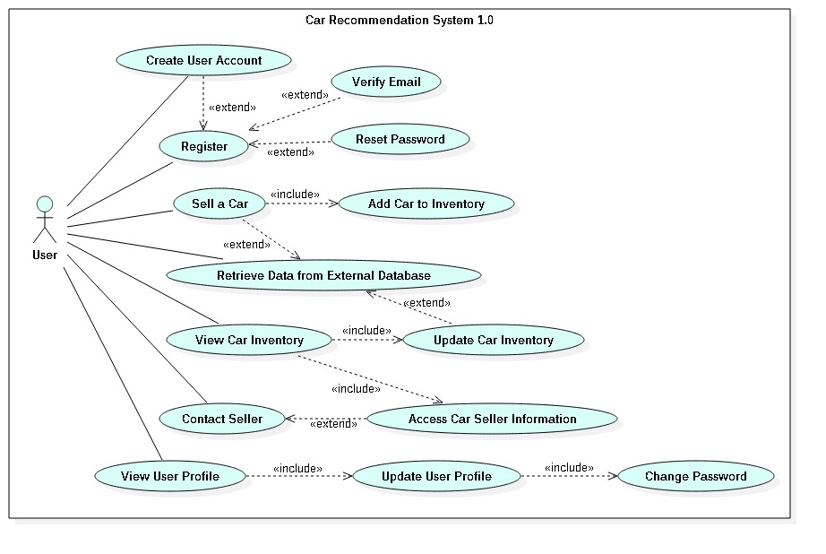

**Figure 1.01** – Use Case Diagrams



**Figure 1.02** - Package diagram

…

### Dynamic UML Diagrams



**Figure 1.03** - Sequence Diagram of the Recommendation User Story

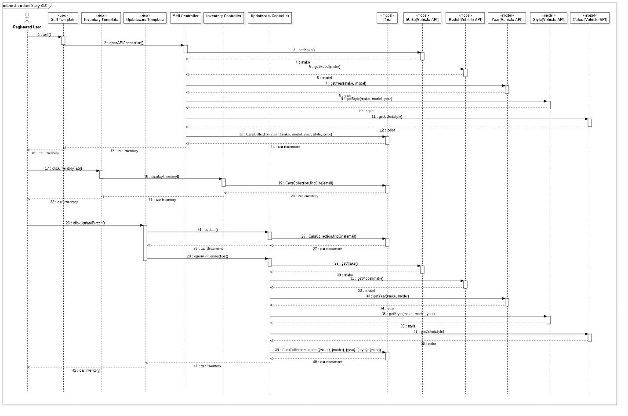

**Figure 1.05** - Sequence Diagram #846 connecting with external database for the sell form.



**Figure 1.06** - The sequence diagram #746 login



**Figure 1.07** - The sequence diagram of #752 car slide



**Figure 1.08** - The sequence diagram of MAP #750



**Figure 1.05**: Database diagram Client and Server

**Figure 1.06**: Database diagram Client and Server.



**Figure 1.07**: Use Case Diagram.



**Figure 1.08**: Class Diagram.

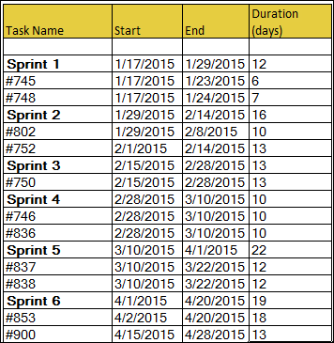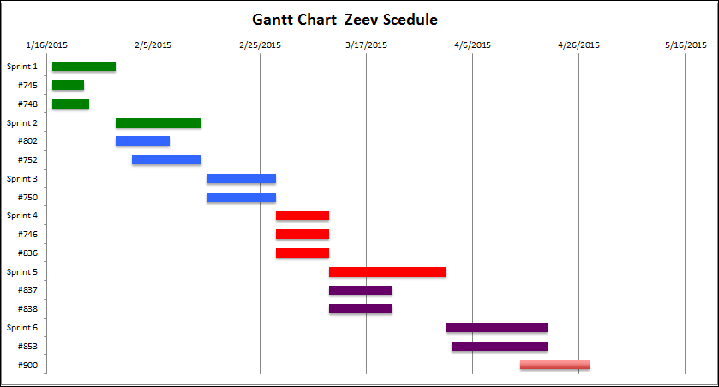

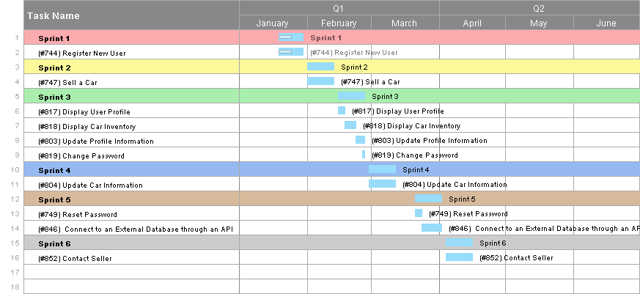

**Figure 1.10**: Gantt Charts

## 

## 

## 

## 

## 

## Appendix B - User Interface Design

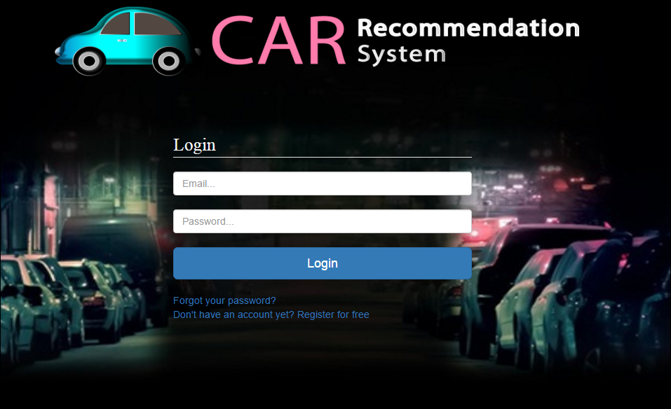

Figure 1.2.4- System Login

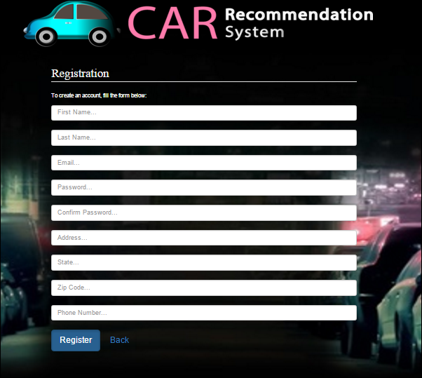

Figure 1.2.5 – System Registration

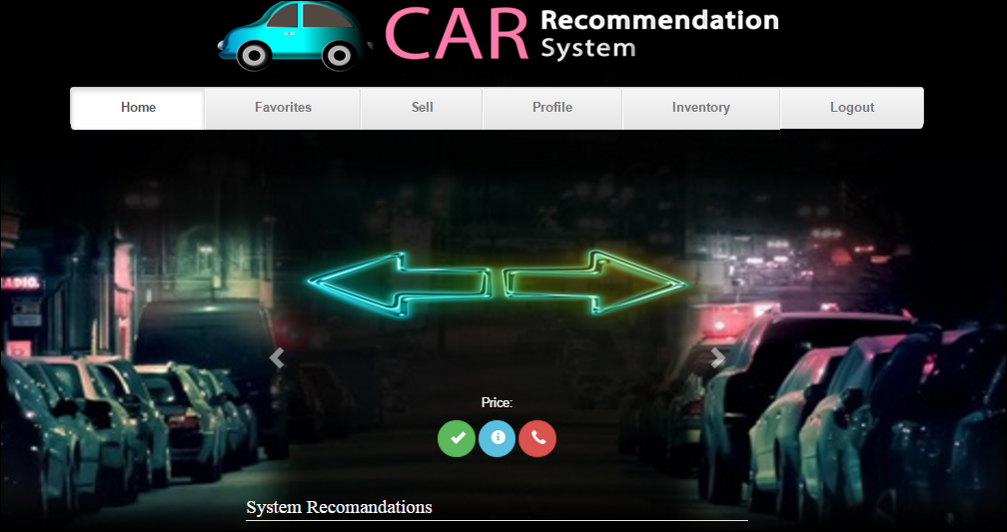

Figure 1.2.6 – Home View for the User ( user can click right or left to go through the cars)

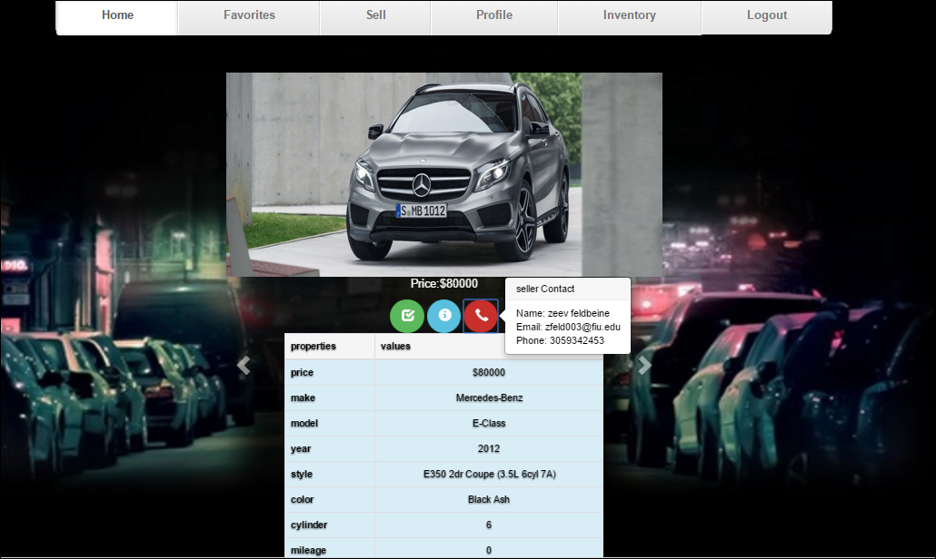

Figure 1.2.7 – user see a car info and it’s contact information

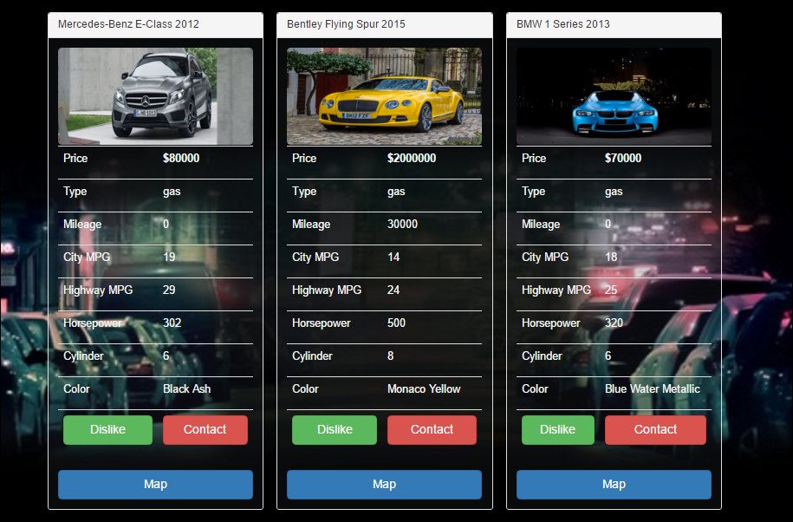

Figure 1.2.8 – a user see a list of cars and their information

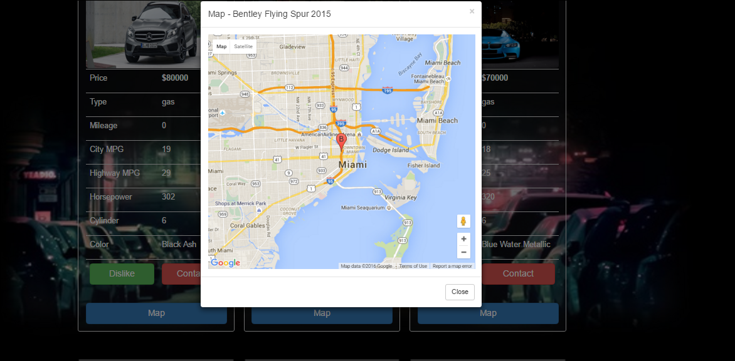figure 1.2.8 - a user see a map of the cars sells

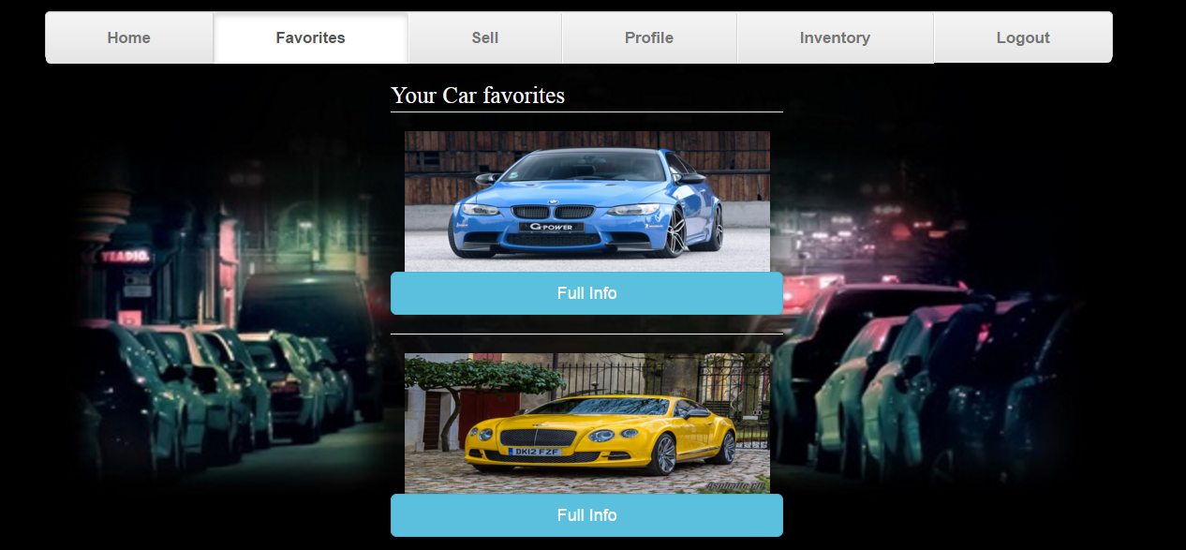

Figure 1.3.0 – user see his favorites

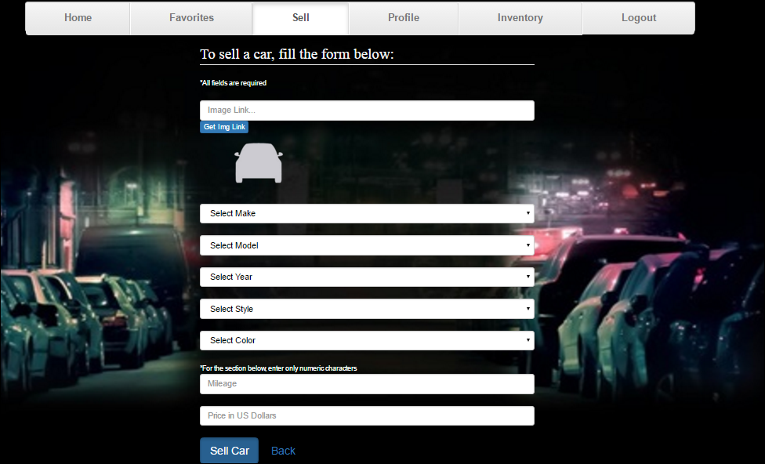

Figure 1.3.1 – Selling Form

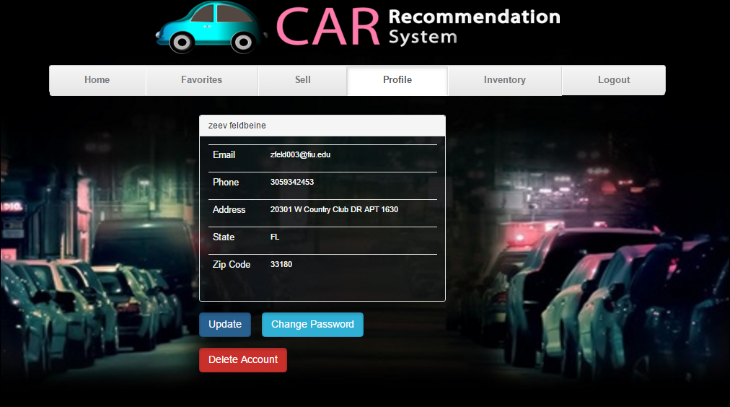Figure 1.3.2 – User Profile Information

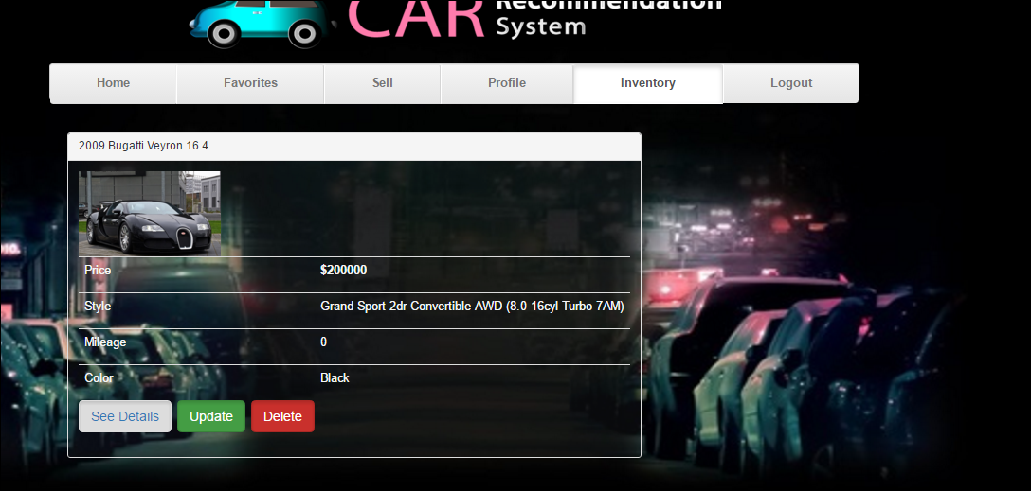

Figure 1.3.4 – User Inventory

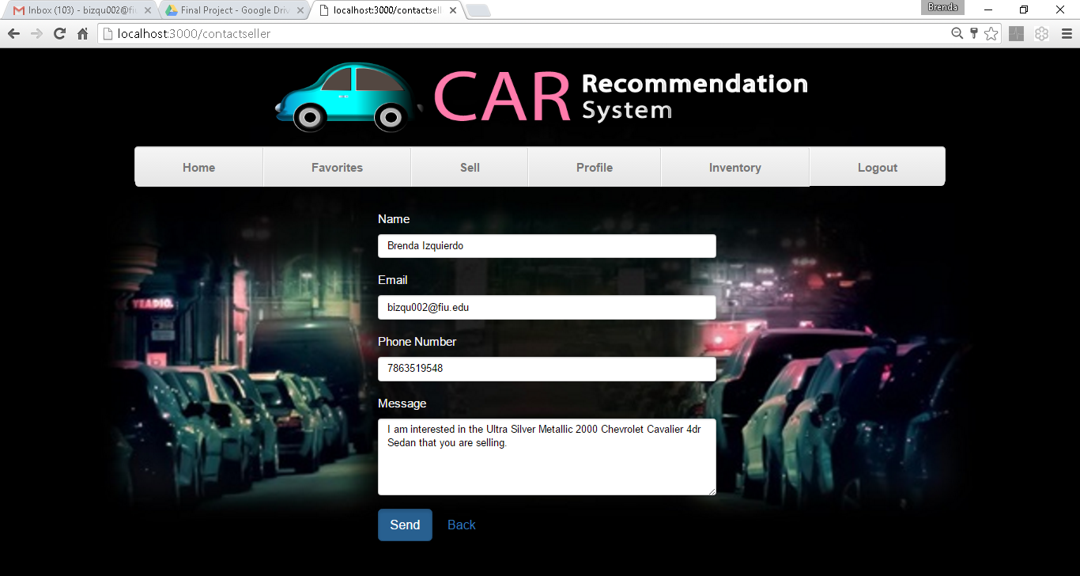

Figure 1.3.5 – Seller-Buyer Communication

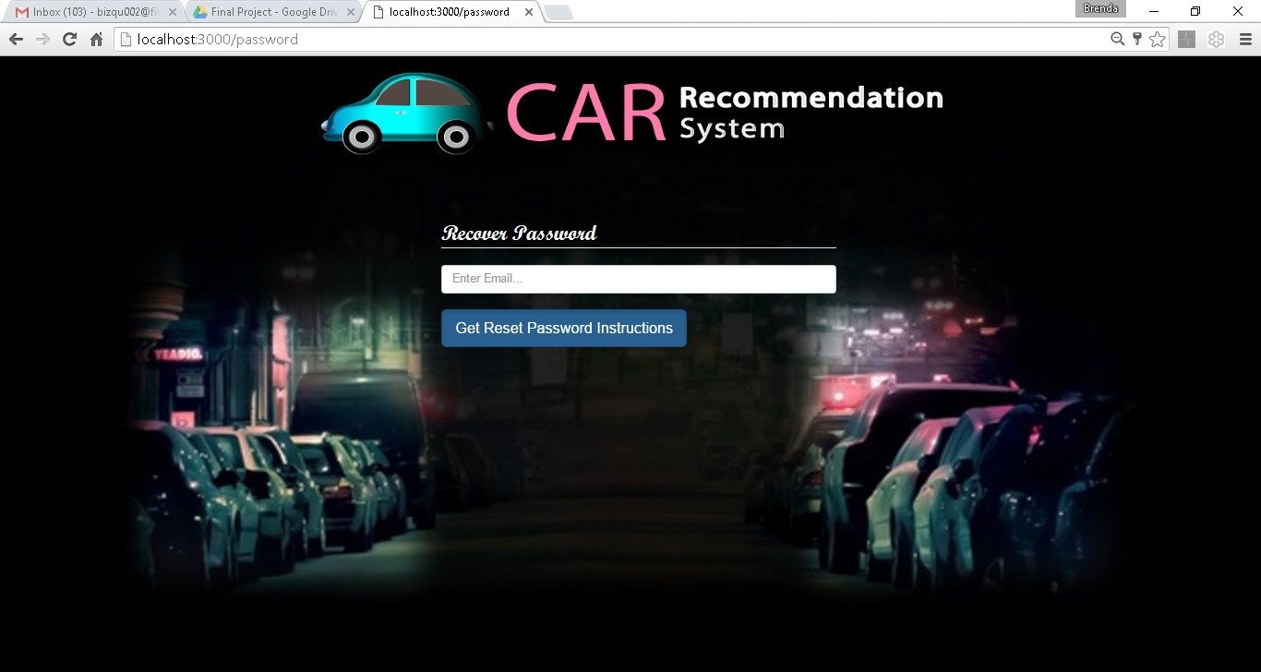

Figure 1.3.6 –Password Reset

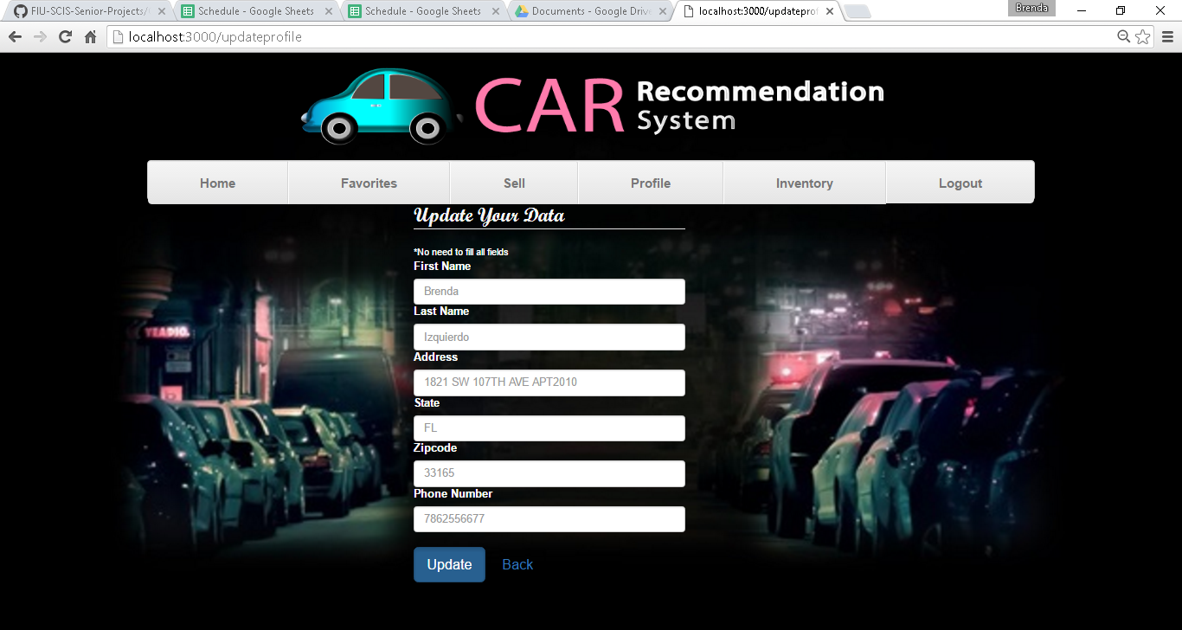

## Figure 1.3.7 – Update Profile Information Form

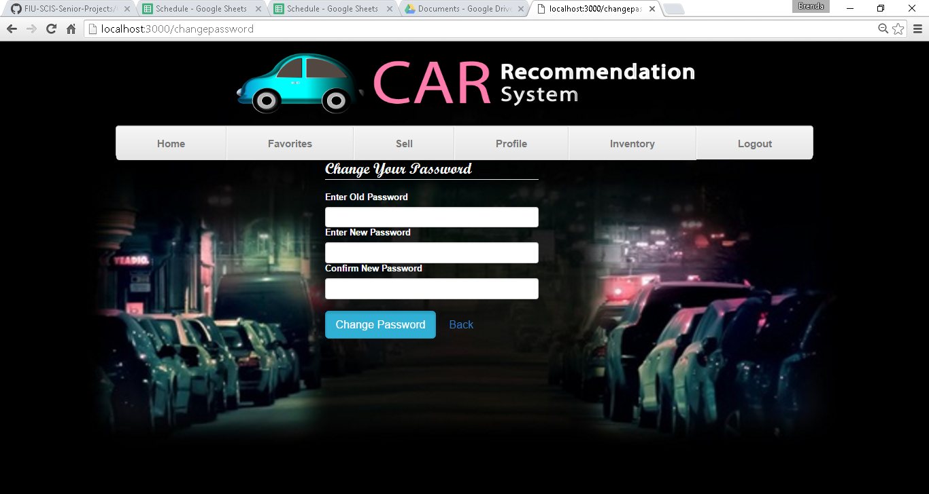

## Figure 1.3.8 – Change Password Form

## Appendix C - Sprint Review Reports

**Sprint 0 Report**

Date: 1/29

Attendees: Brenda Izquierdo, Zeev Feldbeine, David Villegas

Start time: 12:30PM

End time: 1:00PM

After a show and tell presentation, the implementation of the following user stories were accepted by the product owners:

* User Story #744
* User Story #745
* User Story #748

The following ones were rejected and moved back to the product backlog to be assigned to a future sprint at a future Sprint Planning meeting.

* None

**Sprint 1 Report**

Date: 2/12

Attendees: Brenda Izquierdo, Zeev Feldbeine, David Villegas

Start time: 12:30PM

End time: 1:00PM

After a show and tell presentation, the implementation of the following user stories were accepted by the product owners:

* User Story #747
* User Story #752
* user Story #802

The following ones were rejected and moved back to the product backlog to be assigned to a future sprint at a future Sprint Planning meeting.

* None

**Sprint 2 Report**

Date: 2/28

Attendees: Brenda Izquierdo, Zeev Feldbeine, David Villegas

Start time: 07:30PM

End time: 9:30PM

After a show and tell presentation, the implementation of the following user stories were accepted by the product owners:

* User Story #745
* User Story #750
* user Story #802

The following ones were rejected and moved back to the product backlog to be assigned to a future sprint at a future Sprint Planning meeting.

* None

**Sprint 3 Report**

Date: 03/28

Attendees: Brenda Izquierdo, Zeev Feldbeine, David Villegas

Start time: 07:30PM

End time: 9:30PM

After a show and tell presentation, the implementation of the following user stories were accepted by the product owners:

* User Story #745
* User Story #750
* user Story #802

The following ones were rejected and moved back to the product backlog to be assigned to a future sprint at a future Sprint Planning meeting.

* None

**Sprint 4 Report**

Date: 03/28

Attendees: Brenda Izquierdo, Zeev Feldbeine, David Villegas

Start time: 07:30PM

End time: 9:30PM

After a show and tell presentation, the implementation of the following user stories were accepted by the product owners:

* User Story #837
* User Story #838
* user Story #749

The following ones were rejected and moved back to the product backlog to be assigned to a future sprint at a future Sprint Planning meeting.

* None

**Sprint 5 Report**

Date: 04/09

Attendees: Brenda Izquierdo, Zeev Feldbeine, David Villegas

Start time: 07:30PM

End time: 9:30PM

After a show and tell presentation, the implementation of the following user stories were accepted by the product owners:

* User Story #850
* User Story #851
* User Story #852

The following ones were rejected and moved back to the product backlog to be assigned to a future sprint at a future Sprint Planning meeting.

* None

**Sprint 6 Report**

Date: 04/15

Attendees: Brenda Izquierdo, Zeev Feldbeine, David Villegas

Start time: 01:30PM

End time: 2:30PM

After a show and tell presentation, the implementation of the following user stories were accepted by the product owners:

* User Story #850
* User Story #853
* User Story #852

The following ones were rejected and moved back to the product backlog to be assigned to a future sprint at a future Sprint Planning meeting.

* None

## Appendix D - Sprint Retrospective Reports

**Sprint 1 Retrospective**

Date: 1/29

Attendees: Brenda Izquierdo, Zeev Feldbeine

Start time: 9:00

End time: 10:00

What went wrong?

* Did we do a good job estimating our team's velocity?

           The velocity was alright

* Did we do a good job estimating the points (time required) for each user story?

           Points were fine

* Did each team member work as scheduled?

           Yes

What went right?

* Login, Register, and Logout user stories were completely finished, including all documentation.

How to address the issues in the next sprint?

* How to improve the process?
  + Try to finish the code in the first week of the Sprint
* How to improve the product?
  + Connect to an external database to avoid storing data in the back-end
  + Make it more user-friendly

**Sprint 2 Retrospective**

Date: 2/12

Attendees: Brenda Izquierdo, Zeev Feldbeine

Start time: 12:00PM

End time: 1:30PM

What went wrong?

* Did we do a good job estimating our team's velocity?

           The velocity was higher than expected.

* Did we do a good job estimating the points (time required) for each user story?

           Points were fine.

* Did each team member work as scheduled?

           Yes.

What went right?

* The Selling form, along with the Display cars feature were successfully completed

How to address the issues in the next sprint?

* How to improve the process?
  + Assign more points to user stories to allow room for further testing and use cases
* How to improve the product?
  + Emphasize work on the front end
  + Improve communication between team members and product owner

**Sprint 3 Retrospective**

Date: 2/28

Attendees: Brenda Izquierdo, Zeev Feldbeine

Start time: 07:30PM

End time: 9:30PM

What went wrong?

* Did we do a good job estimating our team's velocity?

           The velocity was higher than expected.

* Did we do a good job estimating the points (time required) for each user story?

           Points were fine.

* Did each team member work as scheduled?

           Yes.

What went right?

* The Selling form, along with the Display cars feature were successfully completed
* the favorites, editing profiles and the rest also went very good

How to address the issues in the next sprint?

* How to improve the process?
  + Assign more points to user stories to allow room for further testing and use cases
* How to improve the product?
  + Emphasize work on the front end
  + Improve communication between team members and product owner

**Sprint 4 Retrospective**

Date: 03/14

Attendees: Brenda Izquierdo, Zeev Feldbeine

Start time: 07:30PM

End time: 9:30PM

What went wrong?

* Did we do a good job estimating our team's velocity?

           The velocity was higher than expected.

* Did we do a good job estimating the points (time required) for each user story?

           Points were fine.

* Did each team member work as scheduled?

           Yes.

What went right?

* The recomandation algorithm went good, and the update of the view
* the favorites, editing profiles and the rest also went very good
* The new backend was also very good quality

How to address the issues in the next sprint?

* How to improve the process?
  + Focusing on documantation
* How to improve the product?
  + Emphasize work on the front end
  + Improve communication between team members and product owner

**Sprint 5 Retrospective**

Date: 04/09

Attendees: Brenda Izquierdo, Zeev Feldbeine

Start time: 07:30PM

End time: 9:30PM

What went wrong?

* Did we do a good job estimating our team's velocity?

           The velocity was higher than expected.

* Did we do a good job estimating the points (time required) for each user story?

           Points were fine.

* Did each team member work as scheduled?

           Yes.

What went right?

* The implementation of the API calls to connect to an external database
* The embedding of a view map option for each car
* The distance algorithm

How to address the issues in the next sprint?

* How to improve the process?
  + Focusing on integration
  + Deploying code to a new domain
* How to improve the product?
  + Work on the front-end
  + Read through the all the code and add comments

**Sprint 6 Retrospective**

Date: 04/15

Attendees: Brenda Izquierdo, Zeev Feldbeine

Start time: 07:30PM

End time: 9:30PM

What went wrong?

* Did we do a good job estimating our team's velocity?

           The velocity was higher than expected.

* Did we do a good job estimating the points (time required) for each user story?

           Points were fine.

* Did each team member work as scheduled?

           Yes.

What went right?

* The implementation of the API calls to connect to an external database
* The embedding of a view map option for each car
* The distance algorithm
* The code merging
* Documenting the code

How to address the issues in the next sprint?

* How to improve the process?
  + Focusing on testing and documentation
  + Deploying code to a new domain
* How to improve the product?
  + Work on the front-end
  + Read through the all the code and add comments

# References

Since MeteorJS is a very small community of developers, we had no reference of help from outside (this very fact was one of our challenges, and this is why we are so proud on our code and originality).